 |  | User Guide
 | 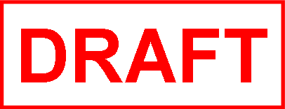  PointMatter |   VERSION 1.01
 | Reporting Solution

Table Of Content
About PointMatter 4
PRS Versions and Features 5
PointMatter Portal Overview 6
Quickstart 7
Applications 8
Ad-Hoc Analysis App 8
Trendlog App 11
Alarm App 14
Energy App 16
Critical Environment App 18
Critical Equipment App 21
Critical Report Configurations 24
Configure and Manage Facets 24
Configure and Manage Standards 26
Configure and Manage Location 29
Configure and Manage Equipment 32
Report Management 35
Report List/View 35
Edit Report 36
Delete Report 37
Download Report 38
Schedule Reports 39
Schedule List/View 40
Report and User assignments 41
Manage User Assignment for Report 42
User Management 43
User Roles 43
Role Permissions 43
List existing users 46
Create a New user 47
Activate or Deactivate a user 47
View and Manage Report Assignment 48
Template Management 49
System & Data Management 50
Tenant Information 51
Glossary of Terms 52
Remove 54

About PointMatter

PointMatter is a software platform that provides reporting solutions for BACnet-compliant Building Management Systems and other IoT devices. PointMatter Reporting Solution (PRS) runs on Microsoft’s Windows 10 and Windows Server operating systems.

This version of PRS supports the Alerton Compass BMS. PRS gives Compass operators the ability to report and analyze the performance of their buildings and monitor critical spaces and equipment. PointMatter communicates with Compass to report on objects such as Points, Devices, Alarms, Energy and Trends for reporting purposes.

The PointMatter platform contains several components. The components are:

- PointMatter Setup App
The PointMatter system is shipped within a zipped file. After the zip file is unpacked, the file PointMatter Setup program is run to install the PointMatter Installation and Configuration App on the computer’s desktop.
- PointMatter Installation and Configuration App
This application does the initial setup and configuration of the PointMatter Reporting Solution. It also is used for the on-going administering of PRS. Refer to the PointMatter Installation and Configuration Guide for instruction on use.
- PointMatter Reporting Solution - This is the application that is used to run reporting and add-on applications. This document is the user’s guide for PointMatter Reporting Solution, referred to as PRS. PRS is accessed using a browser on the Windows computer. The web page is referred to as the PM Portal.

Purpose

This document is intended for end-users of PRS. It provides instructions on how to use the PRS browser-based app to access all the reporting features in PRS. The document assumes that PRS is set up correctly and the manager or end-user is logging into the PRS Portal to run applications and produce reports.

Audience

This document is intended for System Integrators, Dealers, Facility Managers, and other users interested in learning to use the PointMatter Reporting Solution.

PointMatter Reporting Services (PRS) Versions and Features
There are two editions available: BASIC and PREMIUM.

PRS Features & Apps  PointMatter Reporting Solution | BASIC | PREMIUM
PRS VERSION 1.0
BASIC Apps  - Trend App  - Alarm App  - Energy App  - Ad-hoc Analysis App | ☑ | ☑
PREMIUM Apps  - Critical Environment  - Critical Equipment |  | ☑
Standard Templates  Alarm, Energy, and Trendlog  Supports the idea of multiple templates to customize reporting and has one or more pre-installed templates for defining reports. | ☑ | ☑
Custom Templates  PRS provides administrators of the PRS system tools to install custom templates for each app that supports additional templates. | ☑ | ☑
Features  - Portal for Tenant/Site Web UI  - Search/Find Configuration  - User & Report Management  - Report Scheduling & emailing  - Report File Download  - System Activity & SLA reporting  - Embedded SQL Express 2017  - Multi-site Capability  - 10 GB Database Limit Per Site | ☑ | ☑

PointMatter Portal Overview
The PointMatter (PM) Portal is the web user interface that enables Managers and Users to connect to PRS for creating, scheduling and emailing reports. The default access URL to the PM Portal is setup by the PRS administrator using the PointMatter Installation and Configuration App.

PointMatter Apps
PointMatter version 1.0 comes with pre-bundled Apps. The PREMIUM edition adds the Critical Environment and Critical Equipment Apps.

 | APP Name | Description
1 | Ad-Hoc Analysis | Ad-Hoc Analysis of Trends and Alarms
2 | Alarm | Summary report of all alarms and activities. Tracks critical alarms, recurring alarms, and alarms per shift
3 | Trend | Reporting for trendlogs. Displays a single axis with multiple data points on a single chart
4 | Energy | Displays energy consumption and demand
5 | Critical Environment | Track regulatory compliance in critical environments (e.g., Operating Rooms)
6 | Critical Equipment | Measure compliance data during equipment load testing (e.g. testing generators)

Quickstart
Start a web browser. The preferred web browser for PRS is Chrome. Other browsers will work but some UI elements may break.

If you are running PRS on the computer it was installed on, URL for PRS is:

localhost:88/auth/login

The default port is 88. If you used a different port in the PointMatter Installation and Configuration app, be sure to use the correct port number for your site.

If you are accessing PRS from another computer, use the IP address or hostname for that computer instead of localhost.

Logging in for the first time

PRS is shipped with a manager account already setup. Enter the username and password in the login screen:
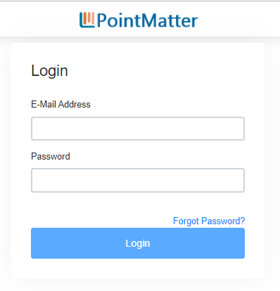

Default Manager Account: pmmanager@pointmatter.com
Default Password: pmmanager@Point$23 (Note: this is case sensitive)

Opening Screen

PRS is a web app. Along the top is the version number, the Tenant name (this is the name you gave during installation), a search bar, global date picker, scheduler, help, and the logout buttons.
On the left side is the navigation menu. In the middle are the PRS apps.

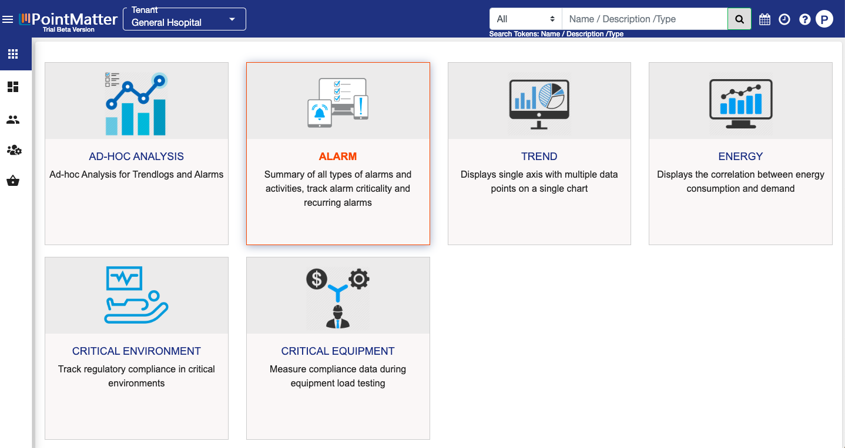

Top Bar

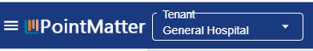

On the left side of the top bar is a button (with 3 horizontal lines) that will expand the left side menu to include descriptions.
Next is the version of PointMatter. The Trial Beta Version is the current version. Its license will expire by the end of 2020.
The Tenant information is next. PRS can be run as a stand-alone system, as a cloud app, and it can have multiple tenants. A tenant is a site. For Alerton Compass, it is one repjob. If your organization runs multiple repjobs, you can access reporting to each from PRS.
Note that in the Trial Beta Version, only one tenant can be active.

This is a picture of the right side of the top bar.

Important note: This section of the top bar contains features that are not fully developed for the Trial Beta Version.

The Search bar is not a complete feature. It will work to search and get information on Alarms, Devices, Energy logs, Points, and trendlogs.

Search will only list information about the device, point, or log. It currently does not do ad-hoc reporting.

The next button is the Global Date Picker. This is not a fully developed feature and should be ignored for this release.

The Clock button shows all Scheduled Reports. If you have scheduled one of the apps to run a report on a recurring basis, the schedule will be listed.

The Help Icon will list the specific version and build of PRS that you are running.

The final button will display as the first initial of your username, in this case a P. Click on this button to access the Logout button.

Sidebar Menu

There are two versions of the sidebar menu. One for Administrators and one for Users. The normal user accounts will only have access to PRS Apps. An administrator account will have additional buttons. This section will cover the administrator sidebar menu.
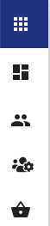

The image above shows the administrator’s PRS sidebar in its unexpanded state. Clicking the 3 horizontal line button directly above this menu, in the top bar, will expand the sidebar to display descriptions next to each icon.

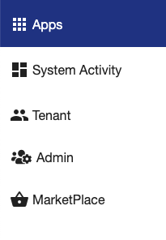

Apps is the default screen when logging into PRS. You can access any app by clicking on it.

System Activity contains a lot of status information on data connections, reporting activity and more. The opening screen for System Activity gives a high-level view of how PRS is functioning.

Tenant will list all of the tenants associated with this instance of PRS. For the Trial Beta Version, this will only list one tenant. If you click on the Tenant name in the middle of the screen, it will display the contents of PRS’s config.ini file (located in the c:\pointmatter… directory tree). This file is normally updated by running the PointMatter Installation and Configuration App. Advanced users can edit this file directly. Looking at the config.ini file will provide information on how PRS is configured.

Admin is used to manage users and to manage reports.
You can add and deactivate users. There are two types of users - administrators and users.
The manage reports section lets you edit any report that you have permissions to edit - if the account is an admin account, you can edit any report for any user. From this section you can give access to a report to any user, schedule the report to run, and run the report.

Applications
This section provides details on each PRS application. Ad-Hoc, Alarm, Trend, and Energy are reporting apps included in the Basic version of PRS. The Critical Environment and Critical Equipment apps are included in the Premium version of PRS.

Ad-Hoc Analysis App
Note 1: this app will be updated with a new UI in an upcoming release. It will be given two buttons - Ad-hoc Alarm Reporting and Ad-hoc trendlog reporting. In the current UI, the user must click “Show all alarms” or “Show all trendlogs” to report on either alarms or trendlogs.

Note 2: The Ad-hoc Analysis app will only report on data that is in the PRS database. In the PointMatter Installation and Configuration application, the administrator selected what data to collect. The options are:
- Send All Alarm History. This is the default. All alarm data is available in the PRS database.
- Send All Priority History. This will send interval data on a scheduled basis (default is every hour) for trendlogs that are included in a PRS report. If a trendlog is not included in a PRS report, no data for that point will be in the PRS database.
- Send All Trendlog History. This will schedule every trendlog in the BMS to be sent to the PRS database. If this is scheduled, it will update the database every hour by default.
Warning: This may be a large amount of information. If greater than 10 gigabytes, this will cause PRS to fail.

Note 3. A future enhancement will be to allow the user to pull specific trendlog data into the PRS database on an ad-hoc basis. For instance, to check a room’s temperature for the past 1 week.

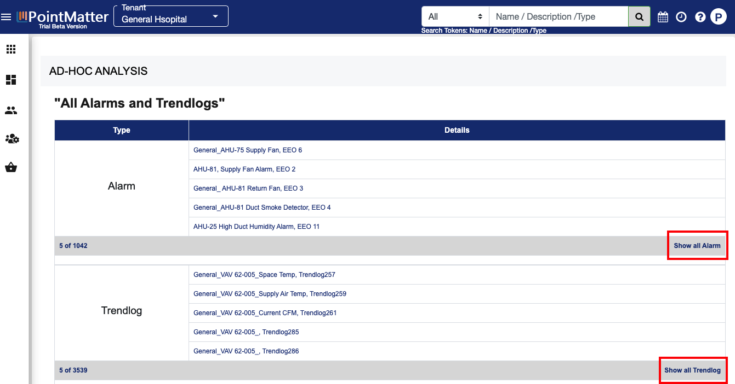

After selecting the Ad-Hoc Analysis App from the Apps menu, the application will display a list of the first 5 configured Alarms and Trends.

To report on an alarm or trend, click on the “Show All Alarms” or “Show All Trends”. This will switch the app to show a listing of all configured alarms or trends. The example below shows all trendlogs:

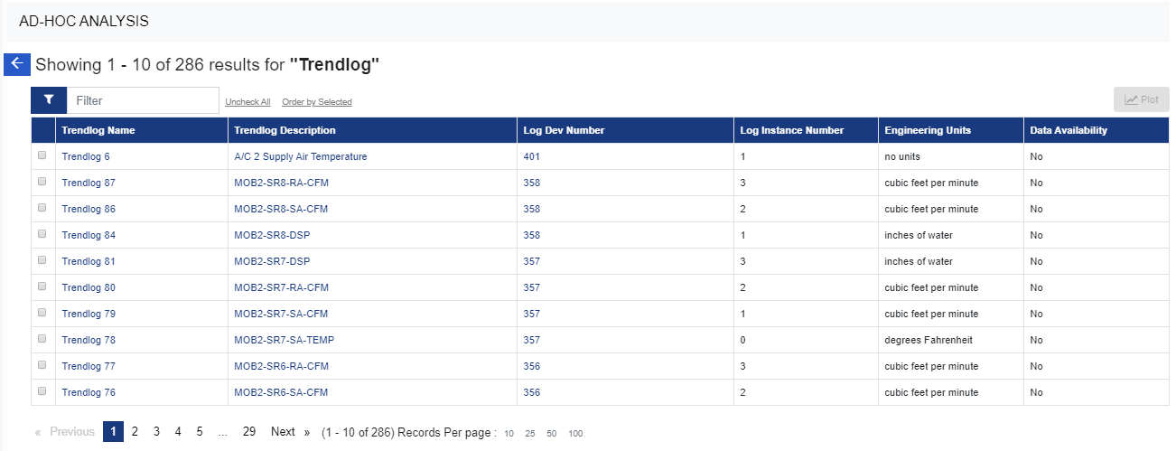

All the columns in the table view are sortable.

At the top of the table is a filter. As you type, the filter will be applied.

To get the detailed information on a specific object, click on the hyperlinks for Trendlog Name or Trendlog Description.

Important:
If data is available for the trendlog, the Data Availability column will have a “Yes” in it. If this column lists “No”, no data for that point exists in the PRS database. See notes at the start of this section.
All alarm data is stored in the PRS database. If Compass does not have an instance of an alarm, that alarm will be listed as “No” in the PRS data availability.

Create an Ad-Hoc Report

Step 1
Sort the Data Availability column by clicking on the Data Availability header in the table.

Step 2
Use the filter to find the trend you are looking for or page through the list of using the numbers at the bottom of the screen.

Step 3
Select the trendlog or multiple multiple trendlogs from the list. You can select up to 10 trendlogs to view in a single ad-hoc report.

Step 4
Click on the Plot button to create the report.

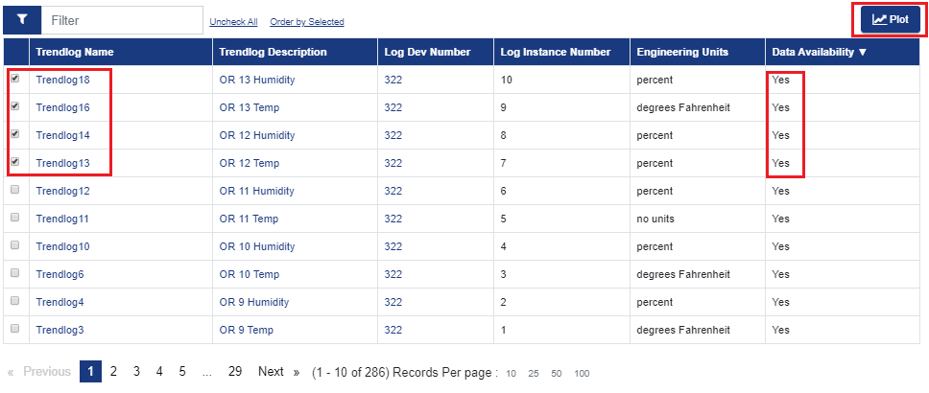

Step 4: Click on Plot to generate Ad-Hoc report for selected objects
Default Duration, resolution and dates are picked from applications Global Datepicker calendar and report is displayed

Step 5: If you like to change the Duration, Resolution, Start and End dates for the report, make changes and press the “APPLY” button to generate updated report.

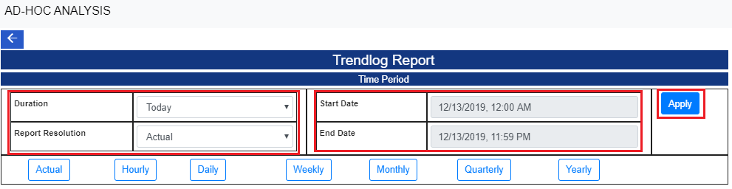

Any value changes made in Global Datepicker will reflect back in Ad-hoc report visualization.

Sample Screenshots for Trends and Alarm reports
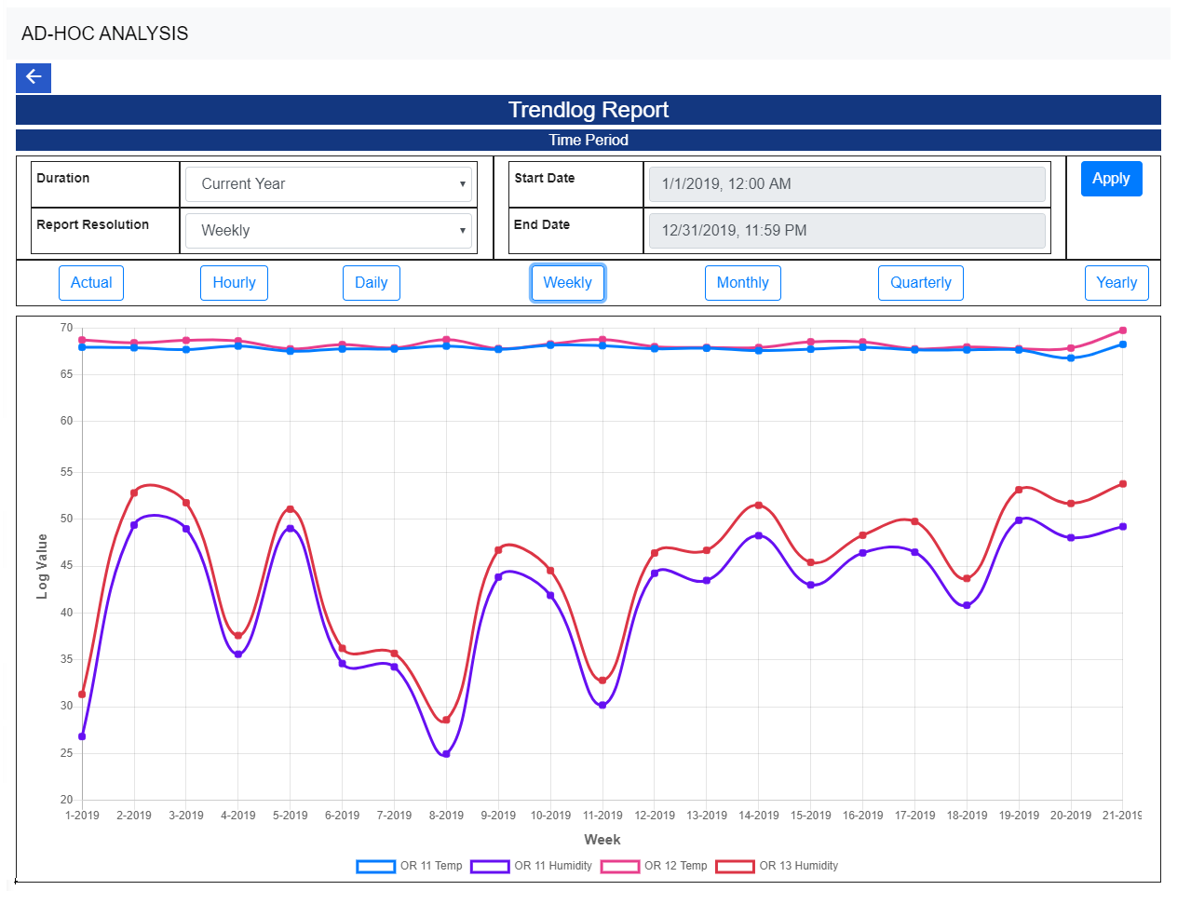
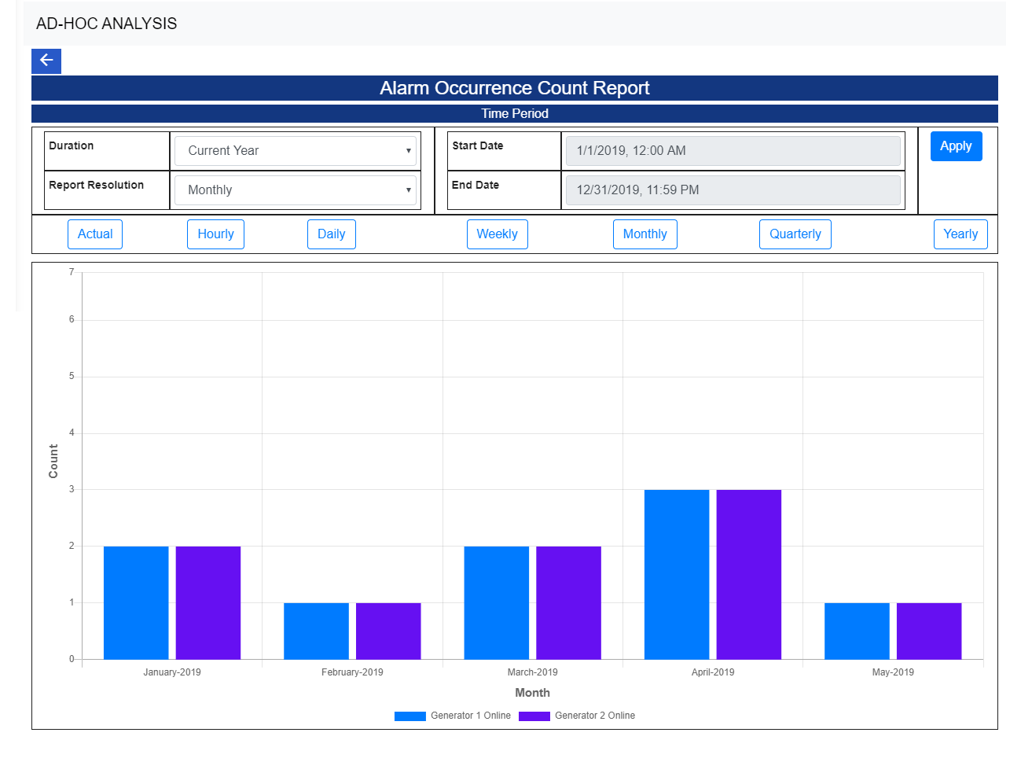

Trendlog App
Creating a Trendlog Dashboard Report

Step 1: Select the Trendlog Dashboard App from APP list
User will see the list of already created reports
This report view will be filtered based on if the logged-in user is PM Manager or PM user.
- PM Manager will be able to see all the reports created for this APP
- PM users will see the list of reports which are created (owned) by him and reports that are assigned to him.

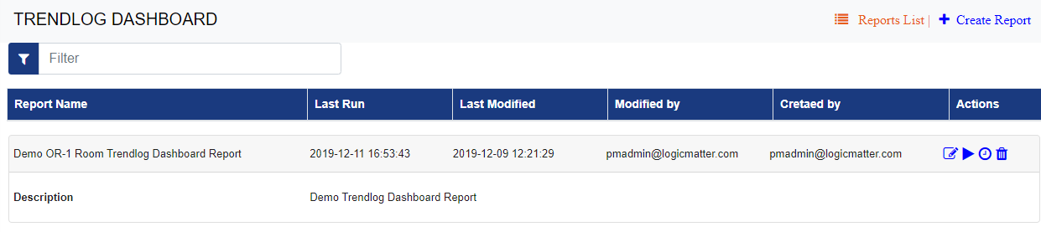

Step 2: Select Create Report option to create a new report
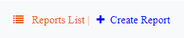

Step 3: Provide Report parameters. All “*” marked parameters are required parameters.

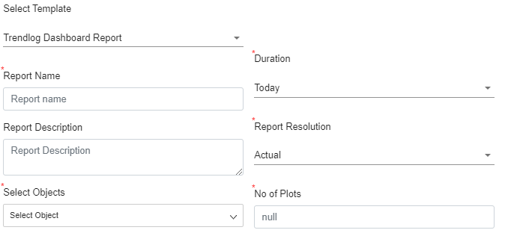
- Select Report template to use
- Provide Name and Description of the report
- Select the duration for the report from the predefined values or select a custom Start and End dates
- Select the report resolution - By default the resolution will be selected based on the duration selected for the best view of the report.
- Select Trendlog objects from the object list
- No of Plots to view per page of the report
Hover over the parameter labels to get the details about the parameters.

Step 4:
Press “Preview” to run a Preview for the report. Once you have the data and report format correct press “Save” to save the report
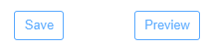

Example Report screen for Trendlog DashBoard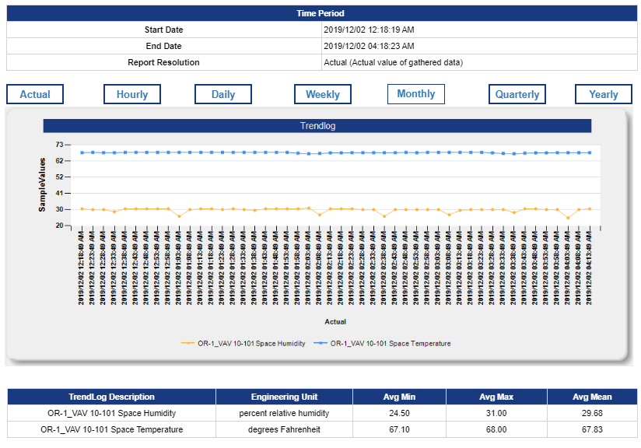

Alarm App
Creating the Alarm Summary Dashboard Report

Step 1: Select the Global Alarm Summary App from APP list
User will see the list of already created reports
This report view will be filtered based on if the logged-in user is PM Manager or PM user.
- PM Manager will be able to see all the reports created for this APP
- PM users will see the list of reports which are created (owned) by him and reports that are assigned to him.

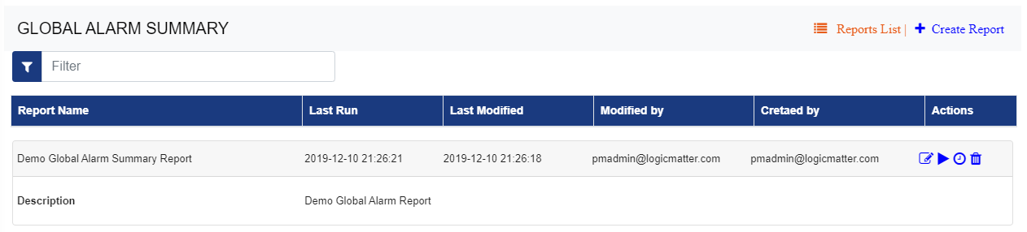
Step 2: Select Create Report option to create a new report



Step 3: Provide Report parameters
All “*” marked parameters are required parameters.

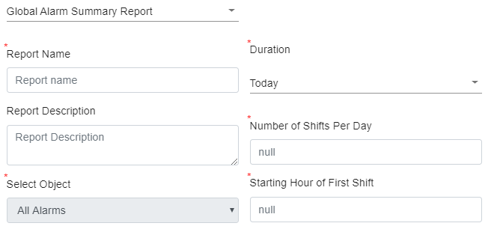
- Select Report template to use
- Provide Name and Description of the report
- Select the duration for the report from the predefined values or select a custom Start and End dates
- Select the report resolution - By default the resolution will be selected based on the duration selected for the best view of the report.
- Select Alarm objects from the object list - By Default for the global Alarm summary template, all Alarms are selected.
- Select Number of Shifts per day - to have the Alarms categorized by Shifts - the default value for the number of shifts are set to 3
- Select the Starting hour for the first Shift

Hover over the parameter labels to get the details about the parameters.

Step 4:
Press “Preview” to run a Preview for the report. Once you have the data and report format correct press “Save” to save the report


Example Report screen for Global Alarm Summary report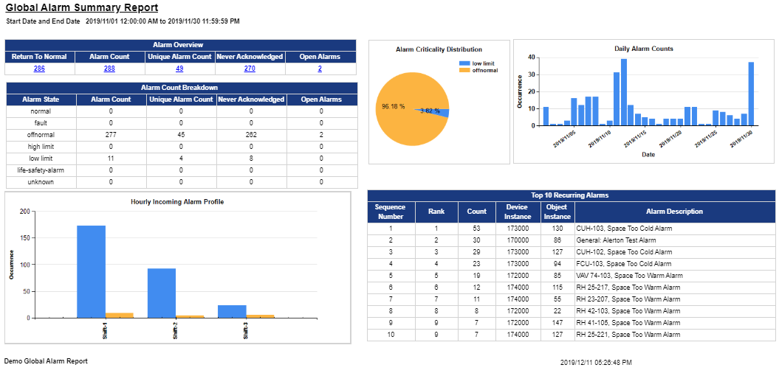

Energy App

Creating the Energy Dashboard Report
Step 1: Select the Energy Dashboard App from APP list
User will see the list of already created reports
This report view will be filtered based on if the logged-in user is PM Manager or PM user.
- PM Manager will be able to see all the reports created for this APP
- PM users will see the list of reports which are created (owned) by him and reports that are assigned to him.

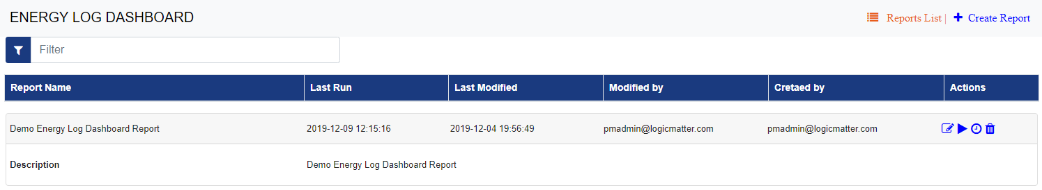

Step 2: Select Create Report option to create a new report



Step 3: Provide Report parameters
All “*” marked parameters are required parameters.

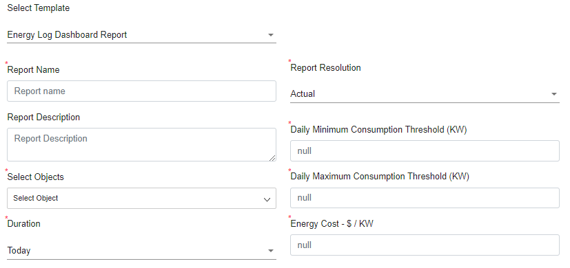
- Select Report template to use
- Provide Name and Description of the report
- Select the duration for the report from the predefined values or select a custom Start and End dates
- Select the report resolution - By default the resolution will be selected based on the duration selected for the best view of the report.
- Select Energy Log objects from the object list - By Default, no objects are selected.
- Provide value for the Daily Maximum and Minimum consumption threshold ins KW
- Provide Energy Cost value ($ per KW) for - this will be used to calculate the total cost

Hover over the parameter labels to get the details about the parameters.

Step 4:
Press “Preview” to preview the report. Once you have the data and report format correct press “Save” to save the report


Example Report screen for Energy Dashboard report
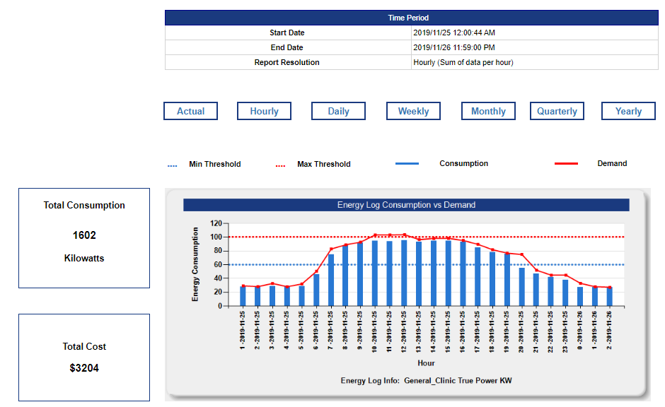

Critical Environment App
Critical Environment reports are created to track the regulatory compliance for defined locations and facets to track compliance.
These reports use the defined Standards against each facet to track the compliance which is associated with a defined location.

Read more on these section to
- Configure and manage Standards
- Configure and manage facet
- Configure and manage Locations

Create a Critical Environment report
Step 1: Select the Critical Environment App from APP list
User will see the list of already created reports
This report view will be filtered based on if the logged-in user is PM Manager or PM user.
- PM Manager will be able to see all the reports created for this APP
- PM users will see the list of reports which are created (owned) by him and reports that are assigned to him.

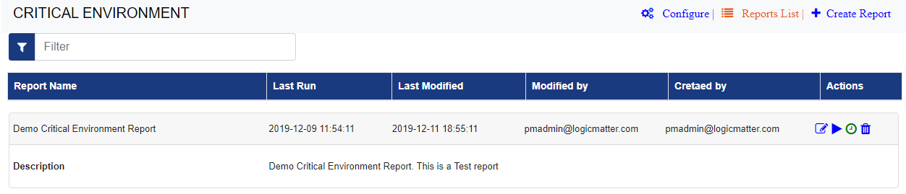
Step 2: Select Create Report option to create a new report



Step 3: Provide Report parameters
All “*” marked parameters are required parameters.

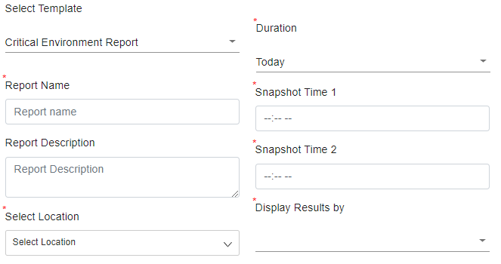
- Select Report template to use
- Provide Name and Description of the report
- Select Location/s to track for compliance reporting - By Default, no location is selected.
- Select the duration for the report from the predefined values or select a custom Start and End dates
- Provide value for the Snapshot time 1 and Snapshot time - These Snapshot times will be used to compare data for compliance reporting based on the defined compliance Standards associated with the selected location
- Select the option to group the compliance report - the user can group the results location wise or facet wise.
Hover over the parameter labels to get the details about the parameters.

Step 4:
Press “Preview” to preview the report. Once you have the data and report format correct press “Save” to save the report

Deviation from compliance will be marked in RED in the report.

Example Report screen for Critical Environment report

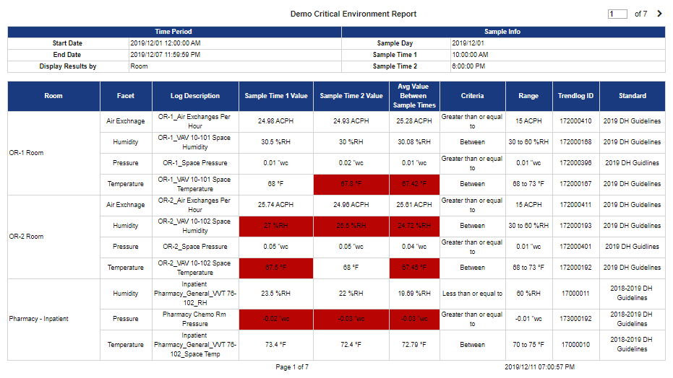
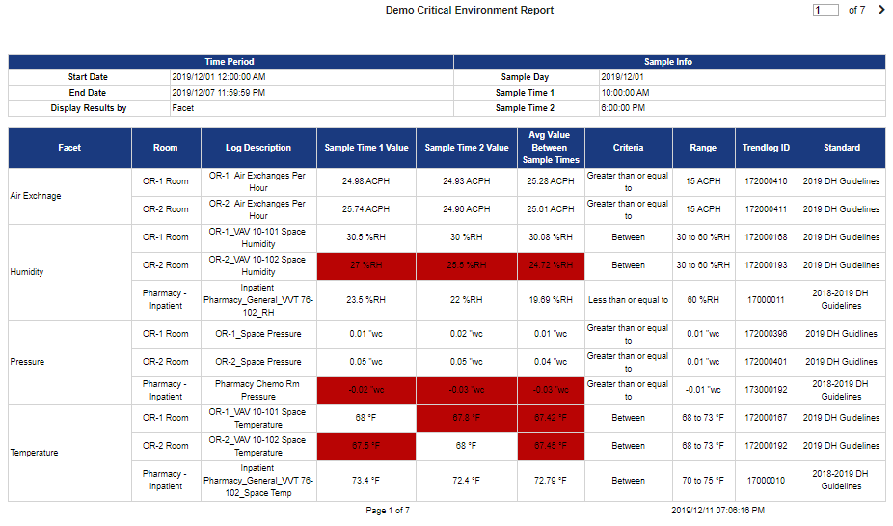

Critical Equipment App
Critical Equipment reports are created to track the regulatory compliance for defined Equipment to track compliance. These reports use the defined Standards against each facet to track compliance, which is associated with a defined Equipment.

- Configure and manage Standards
- Configure and manage Facet
- Configure and manage Equipment

Create Critical Equipment report
Step 1: Select the Critical Environment App from APP list
User will see the list of already created reports
This report view will be filtered based on if the logged-in user is PM Manager or PM user.
- PM Manager will be able to see all the reports created for this APP
- PM users will see the list of reports which are created (owned) by him and reports that are assigned to him.

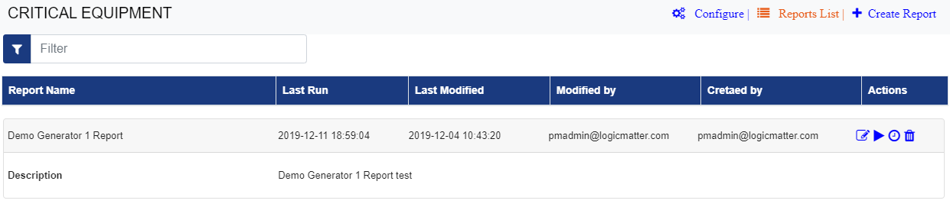
Step 2: Select Create Report option to create a new report



Step 3: Provide Report parameters
All “*” marked parameters are required parameters.
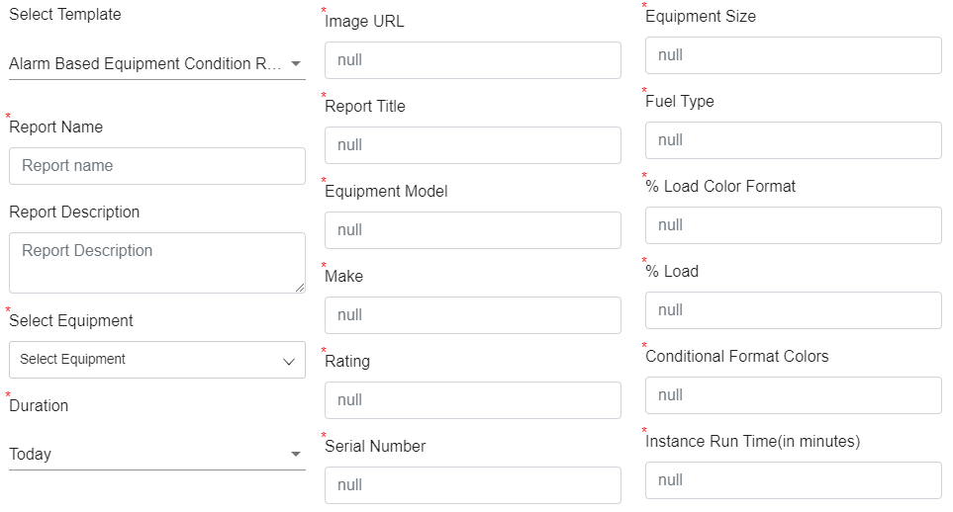
- Select Report template to use
- Provide Name and Description of the report
- Select Equipment from the dropdown to report for compliance reporting - By Default, no location is selected.
- Select the duration for the report from the predefined values or select a custom Start and End dates
- Report Parameters
- Report Title: Report name is displayed in the report (Ex: Generator Report)
- Image URL: It should be a URL of the Equipment and it will display in the report
only PNG image type is supported
- Make: Enter the Equipment type (Ex: Caterpillar)
- Equipment Model: Enter Equipment Model (Ex: Caterpillar 1234)
- Serial Number: Enter the Serial Number of the Equipment (Ex: 9876 or Cat1234)
- Rating: Enter the Capacity of an Equipment (Kilowatts rating Ex: 530KW). This Kilowatts Rating is the size or capacity of an Equipment
- Fuel Type: Enter the fuel type of an Equipment (Ex: Diesel, Petrol, etc..)
- Equipment Size: Enter the size of an Equipment (Ex: Medium, Large, etc..)
- % Load: Load percent accepts three setpoint values. Based on the three setpoint values report will show the color coding for Kilowatts load object (Ex: 30,60,90)
- % Load Color Format: Enter 4 color with ‘,’ separated values, these colors will apply to the third column for KW object in the report (Ex: blue, green, brown, red)
- Conditional Format Colors: Enter three color names with ‘,’ values and these colors will apply for remaining conditions columns in the report (Ex: blue, green, red)
- Instance Run Time(in minutes): Provide the Instance Run time in minutes in the below field, this will be displayed in the report header (besides the equipment image), and It indicates the minimum time period for which a test should run so that it can be called a Test(Ex: 30)
Hover over the parameter labels to get the details about the parameters.
Step 4:
Press “Preview” to preview the report. Once you have the data and report format correct press “Save” to save the report

Deviation from compliance will be marked in RED in the report.

Example Report screen for Critical Equipment report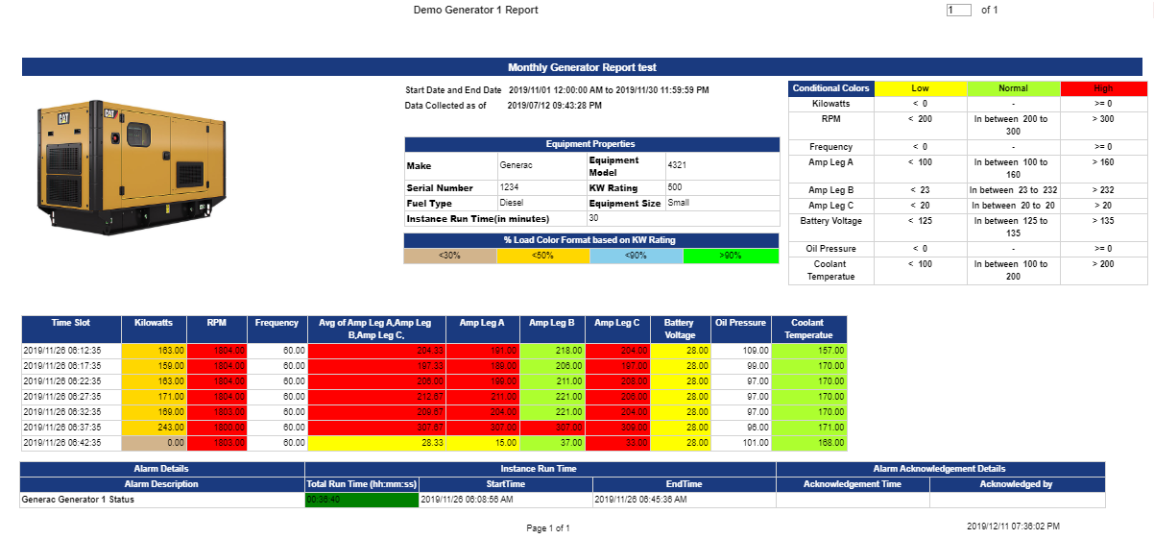

Critical Report Configurations

Configure and Manage Facets
[For Critical Environment and Critical Equipment App]
Facets are defined and added into the system for compliance monitoring for them. These Facets will be used for creating different standards by applying different conditional criteria on the given Facet specific for the standard rules.

The defined Facets are used while creating/updating a Standard.

Click on the Configure link in APP View
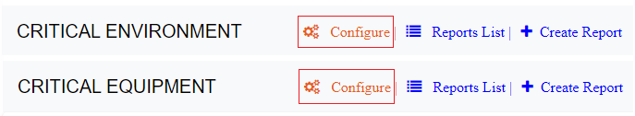
List of Default Facets will be listed in Facet list view under the Facet tab
- User will be able to define/update Facets used by the critical environment and Equipment under this tab in the application.
- The application gives the flexibility to define all the Facets in one single table
- User can filter the table by providing filter text, filter value is applied to all the columns except the Actions column.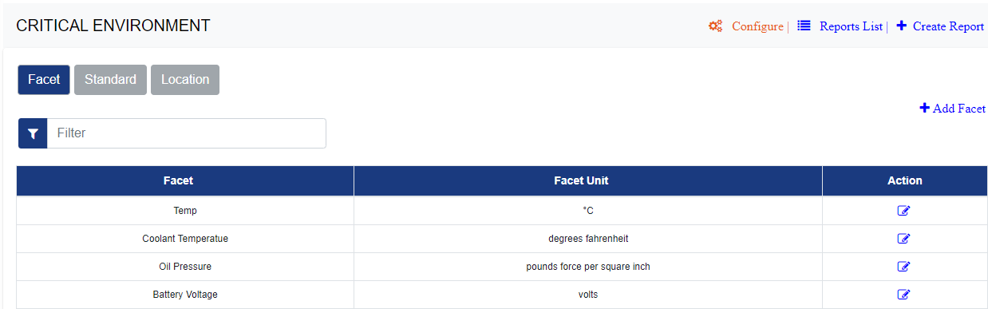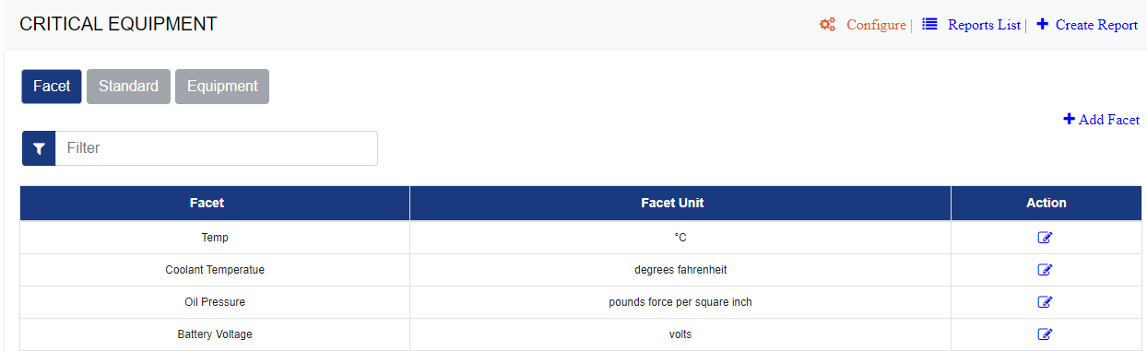
Add New Facet
Select the “Facet” Tab under the configuration section and click on “ADD” Facet
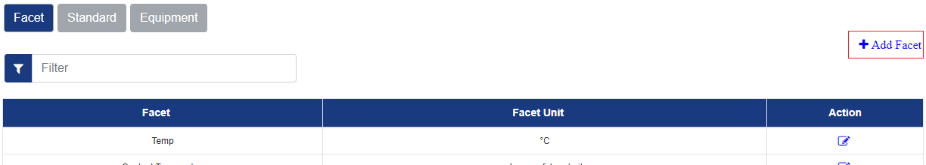
Provide Facet Details like Facet Name and Facet Unit
All “*” marked parameters are required parameters.
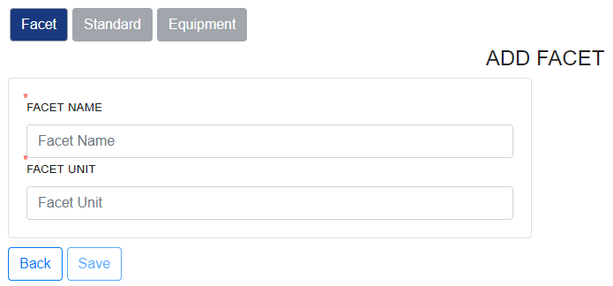
Press SAVE to Facet the facet

Edit Facet
Click on the Edit icon in the Facet list
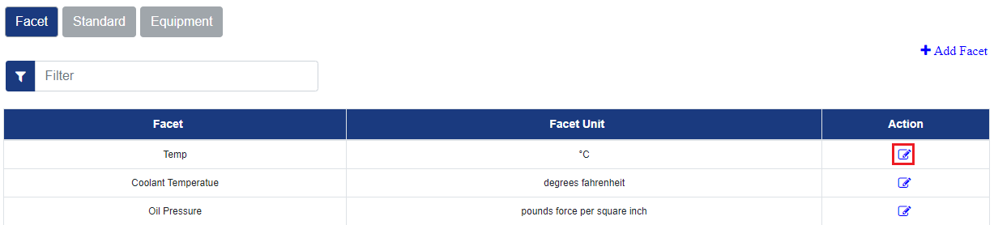
Update the information on Update Facet screen and select “Update”
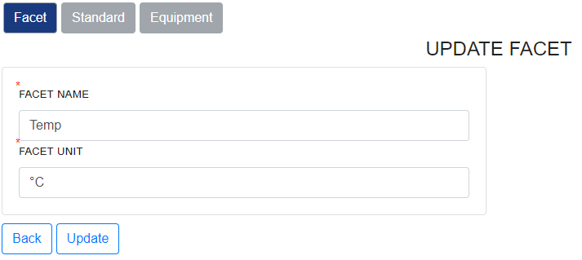

Configure and Manage Standards
[For Critical Environment and Critical Equipment App]

Click on the Configure link in APP View

List of Available Standards will be listed in Standard list view under the “Standard” tab

- Users will be able to define/update the critical environment and Equipment compliance standards under this tab in the application.
- The application gives the flexibility to define all the standards in one single table
- For the Critical environment app, users view the standards applied for specific location by selecting the location in the Location dropdown.
- Users can filter the table by providing filter text, filter value is applied to all the columns except the Actions column.

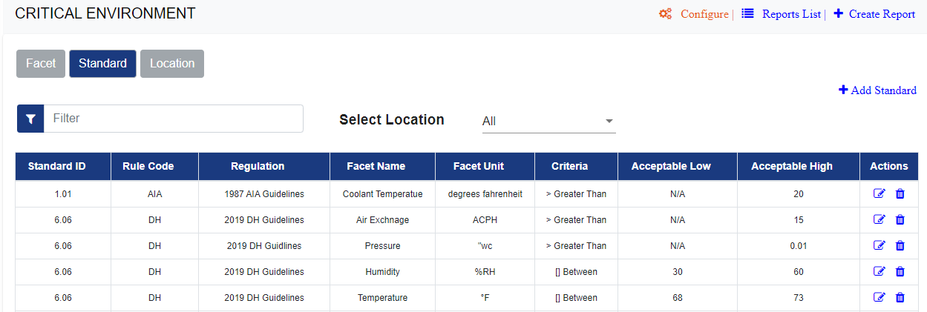
Add New Standard
Select the “Standard” Tab under the configuration section and click on “Add Standard”
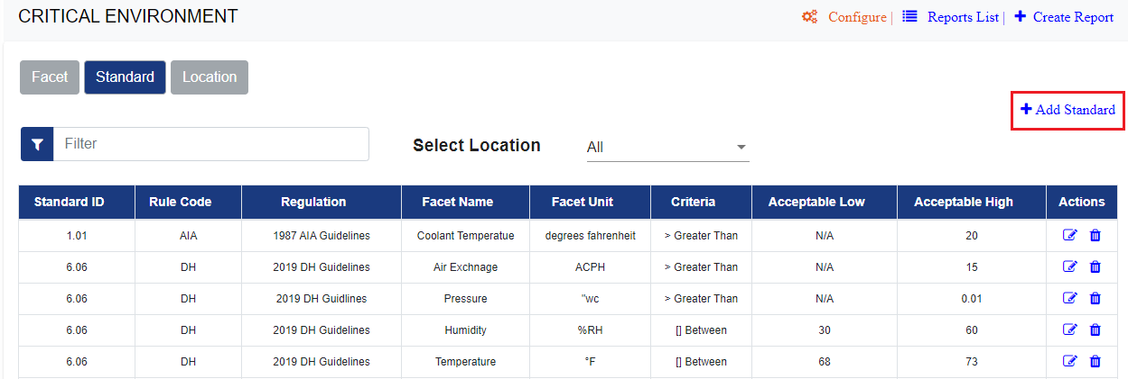
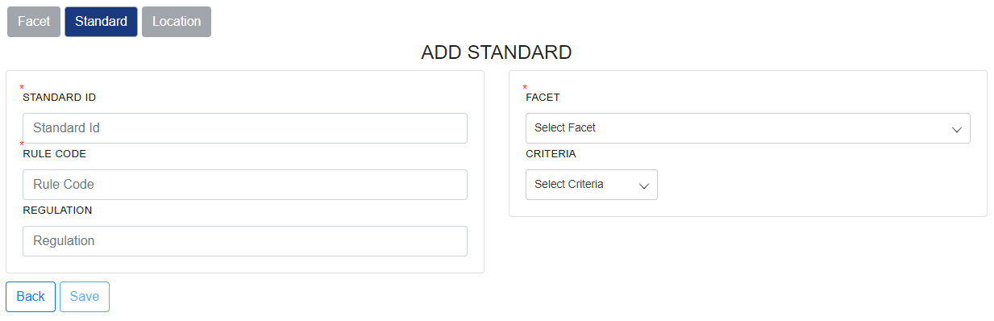
On Add Standard Screen
- Provide unique Standard ID
- Provide Unique Standard Rule Code
- Provide Regulation Name/Description
- Select a Facet from “Facet” drop-down
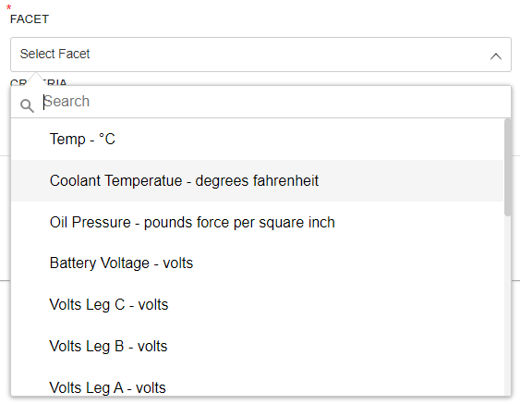
- Select the Criteria to apply on the facet
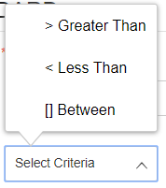
- Provide Acceptable Low and/or High Values depending on the selected criteria
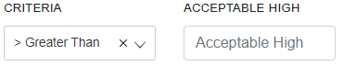
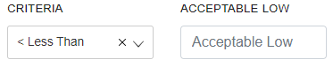
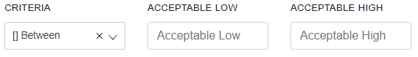

7. Press SAVE to Add a new Standard

Edit Standard
- Click on the Edit icon in the Standard list
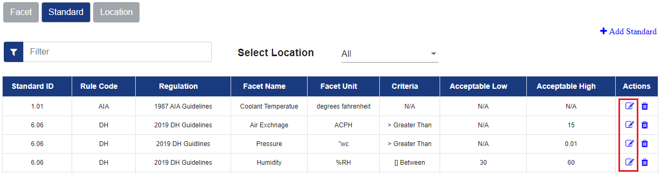
- Update the information on Update Standard screen and select “Update”
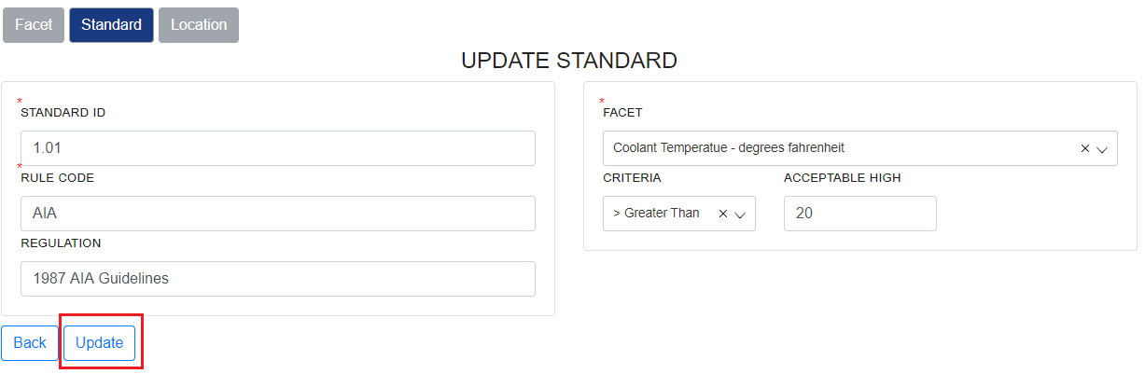

Delete Standard
- Click on the “Delete” icon in the Standard list
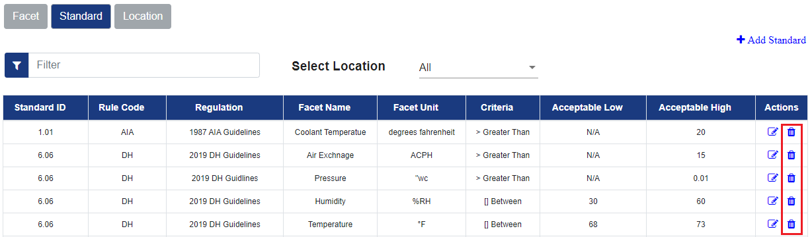
- The application will prompt for the Deletion Confirmation - Message will also show if that Standard is associated with any location or Equipment.
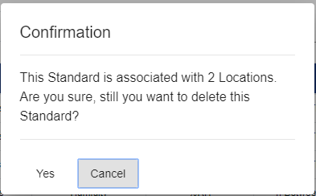
- Press YES to delete the standard, cancel to Abort the operation

Configure and Manage Location
[For Critical Environment App]
Click on the Configure link in APP View
List of Available Location will be listed in Locations list view under the “Location” tab

- Users will be able to define/update Locations used by the critical environment compliance reporting under this tab in the application.
- The application gives the flexibility to define all the Locations in one single table
- Users can filter the table by providing filter text, filter value is applied to all the columns except the Actions column.
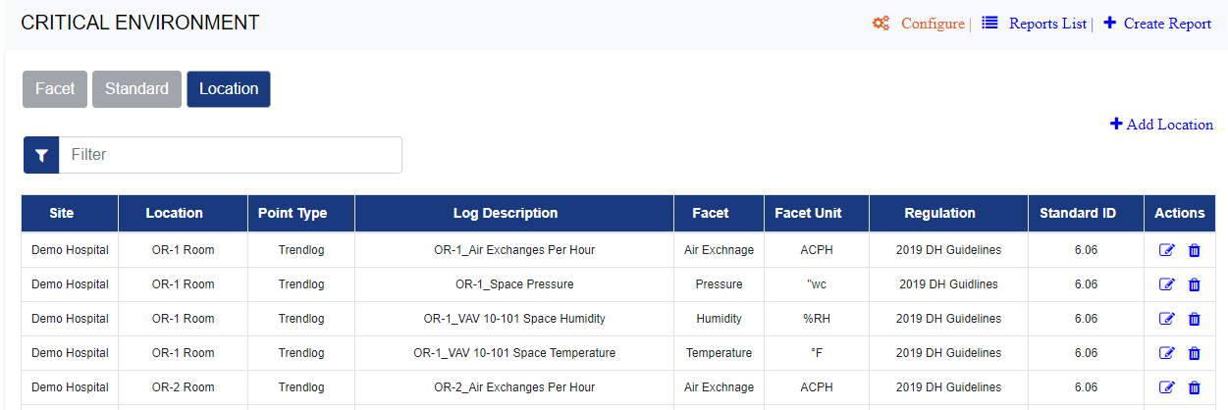

Add New Location
Select the “Location” Tab under the configuration section and click on “Add Location”
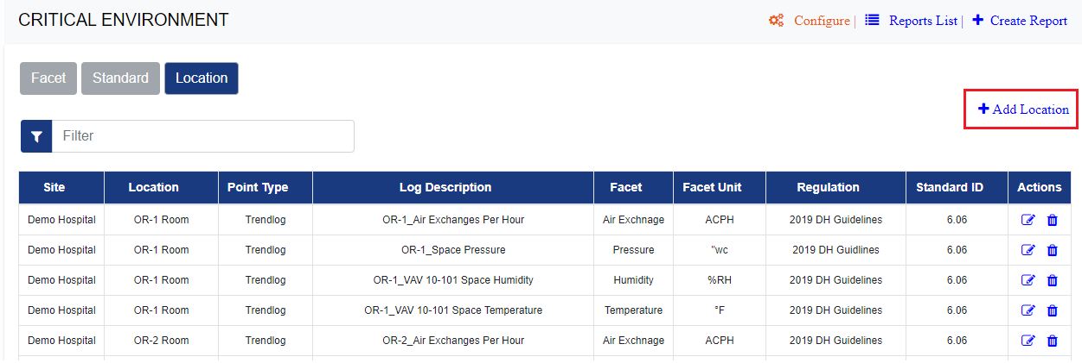
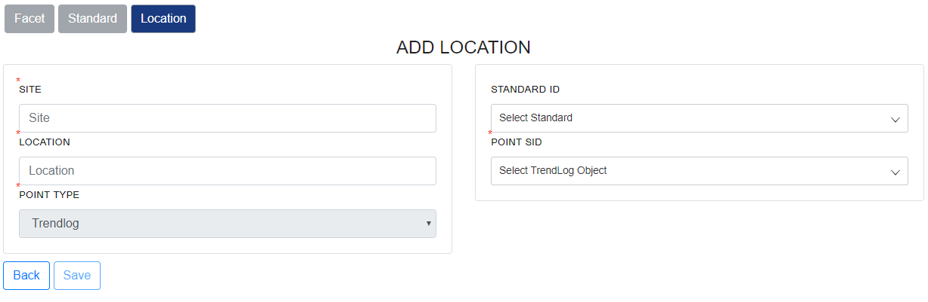
On Add Location Screen
- Provide Site Name
- Provide Location Name
- Provide Point type to Monitor - By default for Critical Environment App point type is “Trendlog”
- Select a Standard ID from “Standard ID” drop-down to associate with the Location
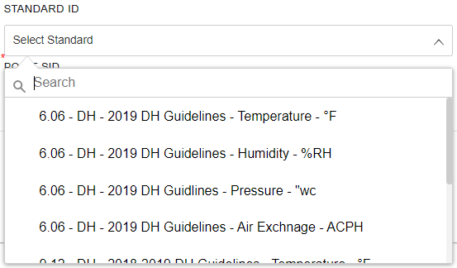
- Select the Single Trendlog to Associate with Selected Point
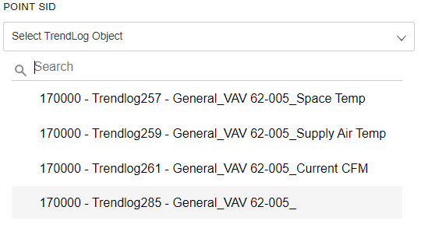
- Press SAVE to Add a new Location

Edit Location
- Click on the Edit icon in the Location list
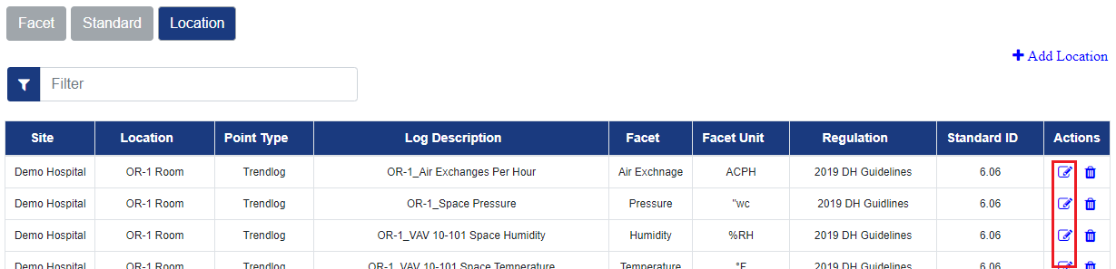
- Update the information on Update Location screen and select “Update”
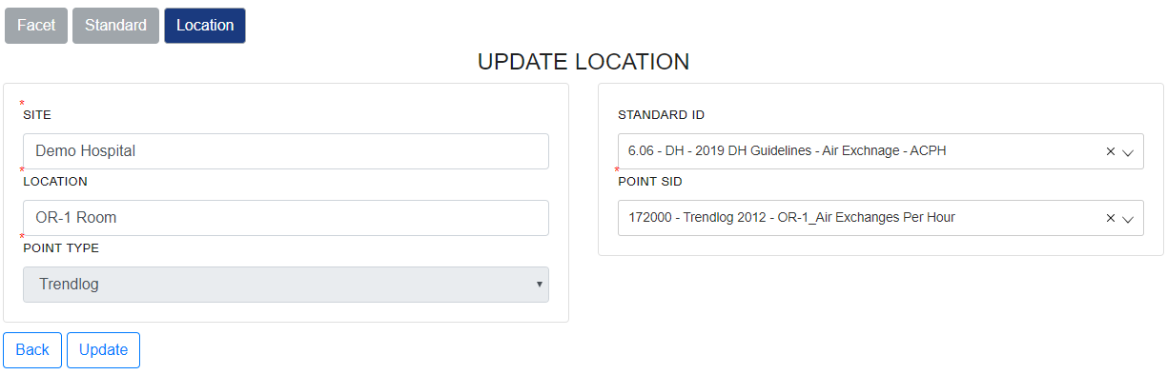

Delete Location
- Click on the “Delete” icon in the Location list
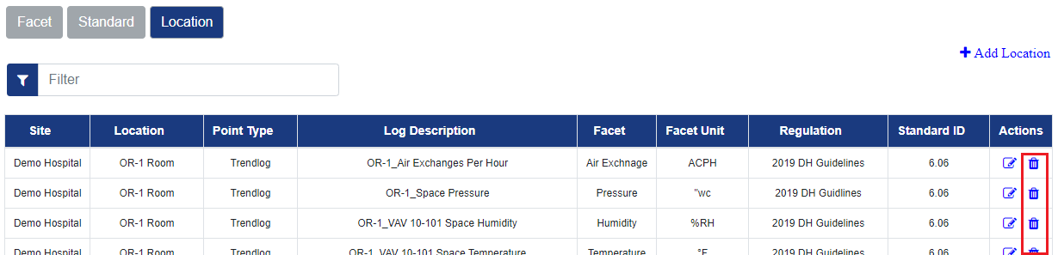
- The application will prompt for the Deletion Confirmation
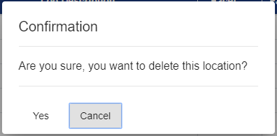
- Press YES to delete the standard, cancel to Abort the operation

Configure and Manage Equipment
[For Critical Equipment App]

Click on the Configure link in APP View

List of Available Equipment will be listed in the Equipment list view under the “Equipment” tab.

- Users will be able to define/update Equipment used by the critical Equipment App for compliance reporting under this tab in the application.
- The application gives the flexibility to define all the Equipment in one single table
- Users can filter the table by providing filter text, filter value is applied to all the columns except the Actions column.

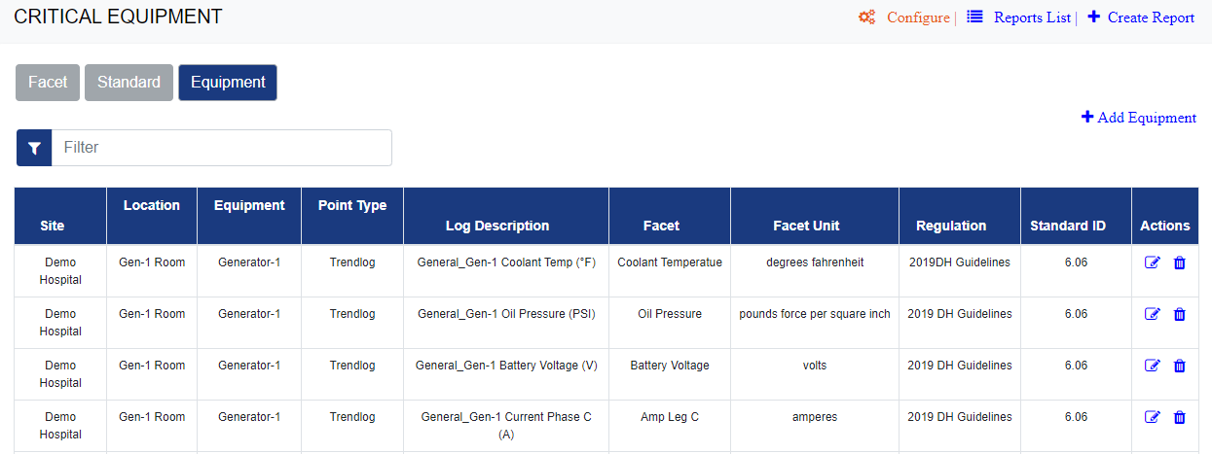

Add New Equipment

Select the “Equipment” Tab under the configuration section and click on “Add Equipment”
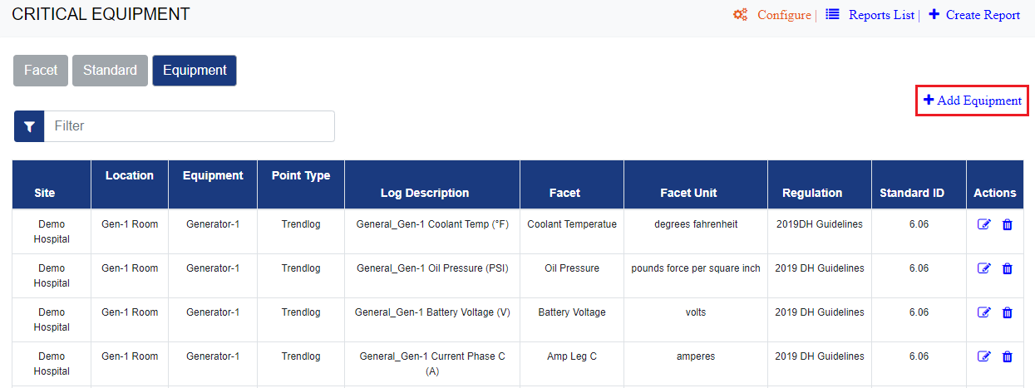

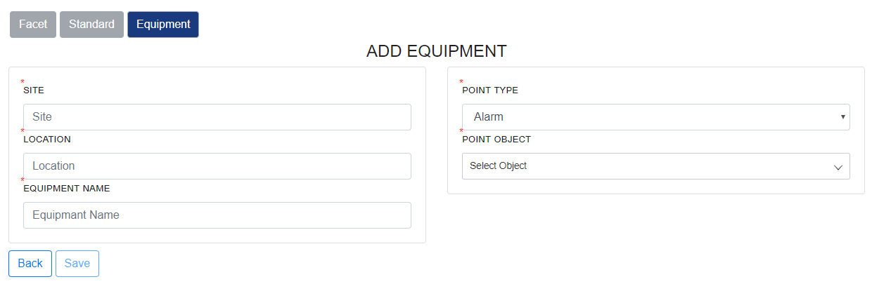
On Add Equipment Screen
- Provide Site Name
- Provide Location Name
- Provide Point type to Monitor
  - For “Alarm” Point type - Select Point object from the Object drop-down list
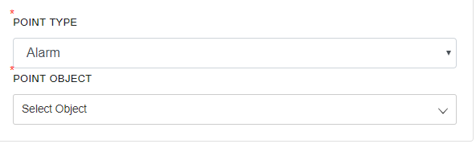
  - For “Trendlog” Point Type - select the Point Object and Standard ID for the Selected point Object
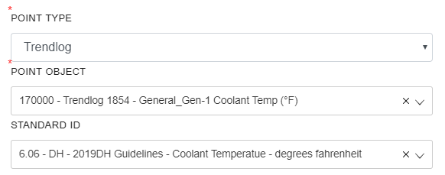
- Press SAVE to Add a new Equipment

Edit Equipment
- Click on the Edit icon in the Equipment list
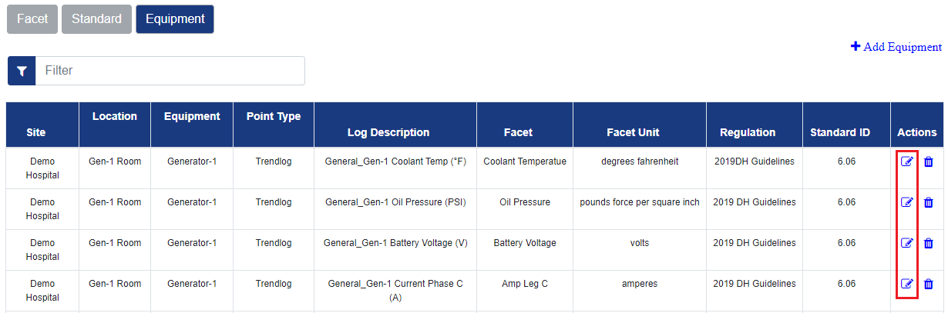
- Update the information on Update Equipment screen and select “Update”
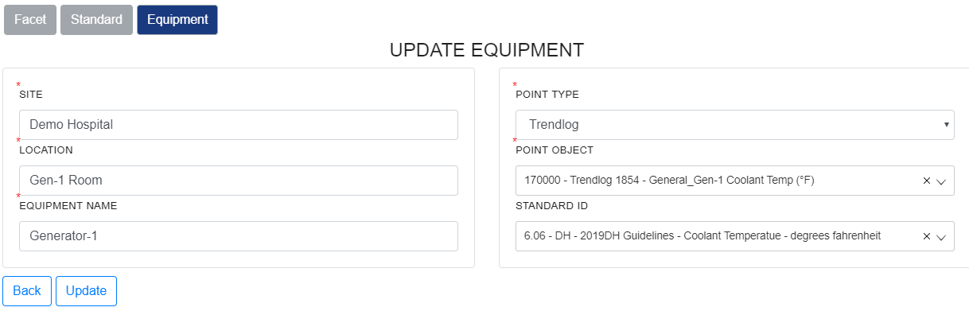

Delete Equipment

- Click on the “Delete” icon in the Location list
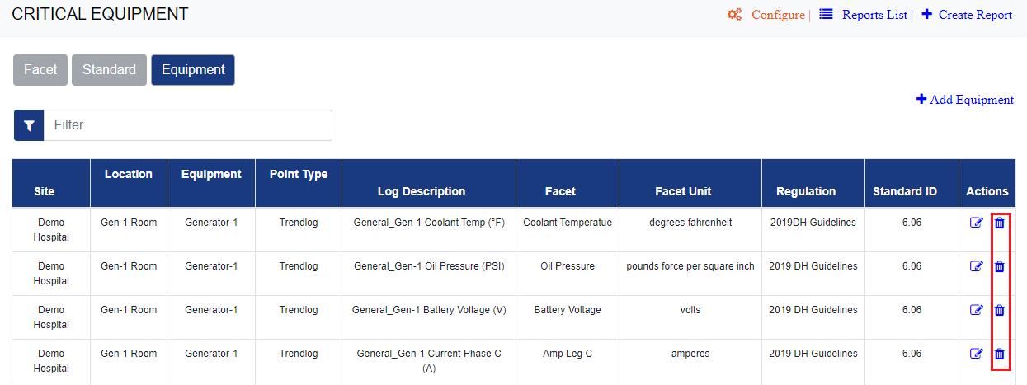
- The application will prompt for the Deletion Confirmation
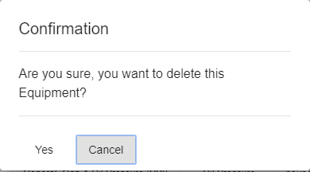
Press YES to delete the standard, cancel to Abort the operation

Report Management
This section describes the common features of managing reports

Report List/View
Each APP has a List of created reports as the landing page. Here users can see a list of all created reports based on the assigned user role.

User with PointMatter Manager role - Can see all created reports for the APP
User with PointMatter User role - can only see the reports which are created by him and reports which are assigned to him.

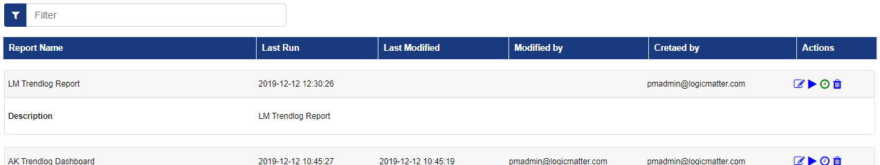

Columns in the Report list view
- Report Name: Name of the report
- Report Description: A brief description of the report provided by the report owner.
- Last Run Time: Date and Time when report was last executed
- Last Modified Time: date and time when the report was last modified.
- Modified by: Email of the the user who modified it
- Created by: Email of the user who is the creator/owner of the reports
- Actions: There are 4 Actions available
  - Edit Report: To Edit and update the report - by clicking on this report will open in respective app in edit mode
  - Run Report : To Run the report - by clicking on this the report will open in the respective app and will Run with the saved parameter values.
Users can also run the report by clicking on the Report name, which is a hyperlink to run the report.
  - Schedule Report: To create a new schedule or update an existing schedule the report - this will open up the scheduler screen for users to provide information and schedule report or edit the already existing schedule.
    - If report is already scheduled, then the “Schedule” icon will appear in green color
  - Delete Report: To delete the selected report - ONLY Report Owner can delete the reports.

Users can filter the table by providing filter text, filter value is applied to all the columns except the Actions column.

Edit Report
Reports can be edited ONLY by the Report Owner and user with PointMatter Manager role.
Assigned users can only change the parameter values and preview the report, but can not update/edit the report.

Users can edit the report click on the EDIT icon in Action column in the report list view or edit it from Report view screen.

Step1: Click on the Edit Icon in the report list view, this will open the report in EDIT mode in respective APP
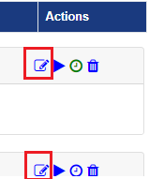

Step 2: Change the report parameters, under the “Parameters” section.
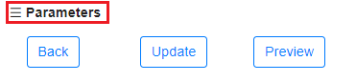

Step 3: After changing report parameters, Press “Preview” to preview the report.
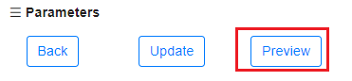

Step 4: Once you have the correct data and report format, press “Update”, this will permanently save the changes made to the report.
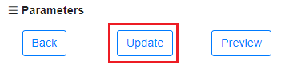

Delete Report
Reports can be edited ONLY by the Report Owner/Creator.

To delete the report click on the Delete icon in the Report List View
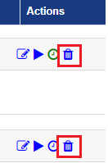

Application will ask for user confirmation for deletion of the report.
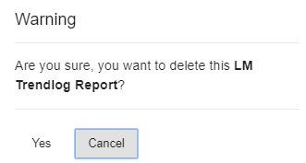

Select “YES” to delete the report and “Cancel” to discard the action.

Download Report
Step 1: Select the report in in APPS “Report list View”

Step 2: RUN the report by clicking on the Run Icon in Actions column
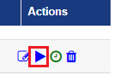
Step 3: On the Report view Banner Click on the icon for PDF, Excel or CSV to download the report in selected format.

Schedule Reports
To configure the scheduled execution of reports and sending email, user can schedule reports created using PointMatter Apps.

Create New Schedule and Send reports by email on a set schedule

Step 1: Click on the APP, you will see the Report List view.
Step 2: In Report list View, Click on “Schedule” icon.
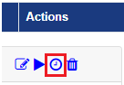
Step 3: New Schedule screen will appear
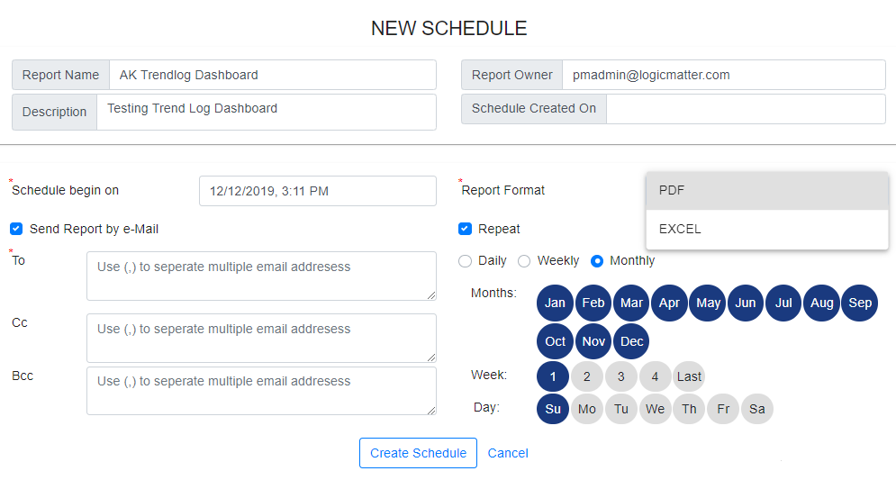
Step 4: Select the Report format (PDF or Excel)
Step 5: Type in the Email Addresses, Separated by commas.
Step 6: Edit date and Time
Step 7 : Edit Repeat - to have a recurring schedule.
Step 7: Click Create Schedule
Reports will be created and emailed on the specified schedule time.

All Repeat schedules will be listed in Schedule List view of the PointMatter.
Use Schedule list view, to edit the existing repeat schedules.

Schedule List/View
PRS provide a feature to view and manage all recurring (Repeat) scheduled reports at one place.

To view the List of all scheduled reports, click on Schedule icon on PointMatter Application banner in the top right.
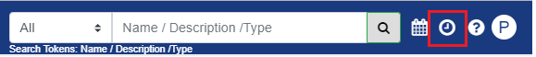
List of schedule reports will open up, where users can view list of all Repeat schedules based on assigned user role.

User with PointMatter Manager role - Can see all created reports for the APP
User with PointMatter User role - can only see the reports which are created by him and reports which are assigned to him.
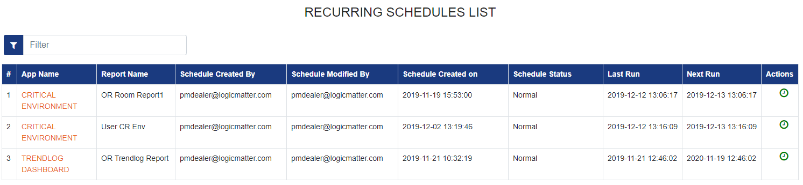
- User can filter the view by providing filter text, filter value is applied to all the columns except the Actions column.
- User can sort the view based on all columns except the action column.
- To edit the schedule click on the “Schedule” icon (in green) under the Action column.

Report and User assignments

PointMatter provides the option to manage different PointMatter Reports from a single place. This option is available for the users having the PointMatter Manager Role.

To View the list of all created PointMatter App reports
- Click on Admin in the side Navigation Menu
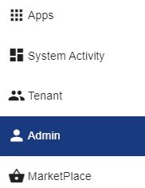
- Click on the “Manage Reports” Tab, this will List of All reports created using PointMatter Apps
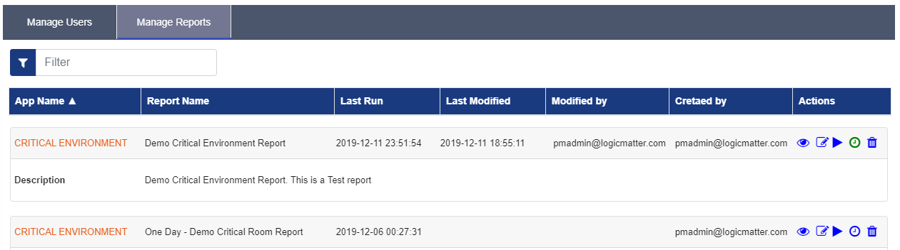
Columns in the Report list view
- APP Name: Name of the App used to create the report
- Report Name: Name of the report
- Report Description: A brief description of the report provided by the report owner.
- Last Run: Date and Time when report was last executed
- Last Modified: date and time when the report was last modified.
- Modified by: Email of the the user who modified it
- Created by: Email of the user who is the creator/owner of the reports
- Actions: There are 5 Actions available
- Assigned Users : To view and manage the assigned users to use the report.
- Edit Report: To Edit and update the report - by clicking on this report will open in respective app in edit mode
- Run Report : To Run the report - by clicking on this the report will open in the respective app and will Run with the saved parameter values.
- Schedule Report: To create a new schedule or update an existing schedule the report - this will open up the scheduler screen for user to provide information and schedule report or edit the already existing schedule.
If report is already scheduled, then the “Schedule” icon will appear in green color
- Delete Report: To delete the selected report - ONLY Report Owner can delete the reports.

Users can filter the table by providing filter text, filter value is applied to all the columns except the Actions column.

Manage User Assignment for Report

Click on the Assigned user icon under the Action Column
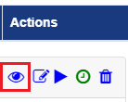
This will show the list of users along with the report details in the top section of the screen

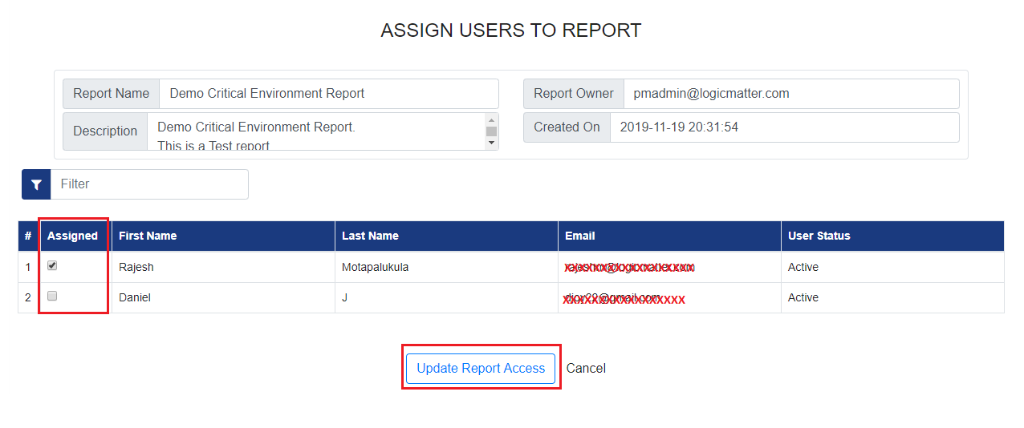
- The “Assigned” column in the list shows the assignment status,
- if Assigned value is checked then this report is assigned to this user
- To revoke the assignment uncheck the “Assigned” value and press “Update Report Access”
- Assigned more users to report by Checking “Assigned” value and press “Update Report Access”.

Report owner name will not appear in the list - it is present in the report description section at the top.
A report is already assigned to the report owner and its assignment cannot be changed.

User Management

Pointmatter provides an option to create and manage different PointMatter users. This option is available for the users having the PointMatter Manager Role.

PRS makes it easy for the SI/FM to create users and assign reports to users. The system provides a standard mechanism of managing users which is described in detail in this section.

User Roles
PRS has two main types of roles supported in PM Portal for managing reporting solutions.

- Manager Role - this user role that can do the following:
  - Create and manage users
  - Assign and Manage reports
  - View and Manage Tenants
  - Access the System Activity Dashboard and SLA reports
- User Role - only access reports
  - Create and manage their own created reports - Execute, Preview, download and Schedule reports
  - Assigned Reports - Execute, Preview, download, and Schedule

Role Permissions
 | Feature | Available for PointMatter Manager | Available for PointMatter User
 | View APP listing | Y | Y
 | System Activity - Dashboard | Y | N
 | System Activity - SLA Reports | Y | N
 | View Tenant Configuration | Y | N
 | View PointMatter MarketPlace | Y | N
 | Search for Objects and reports | Y | Y
 | Global Datepicker | Y | Y
 | Schedule List | Y | Y
 | PointMatter Help | Y | Y
 | Logged in User information | Y | Y
 | User Management | Y | N
 | Creation of PointMatter user | Y | N
 | Report Management and User Assignment | Y | N
 | Tenant information and configuration | Y | N
 | Create/Run Reports | Y | Y
 | Edit Reports | Y | N
 | Delete Reports | N | Y(only for report Owner)
 | Configure and Manage Facets | Y | Y
 | Configure and Manage Standards | Y | Y
 | Configure and Manage Location | Y | Y
 | Configure and Manage Equipment | Y | Y
 | Report Scheduling and email notification | Y | Y

Forgot Password
Click on the “Forgot Password” link to get a password
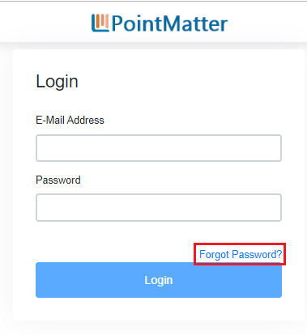
Provide registered email to reset password
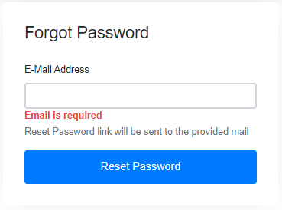

Reset Password
Click on the password reset link in the mail to set a new password
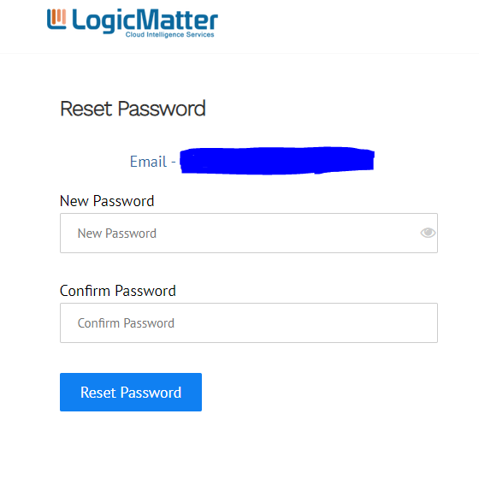

List existing users
- Click on Admin in the side Navigation Menu


- Click on the “Manage Users” Tab, List of All users will be shown

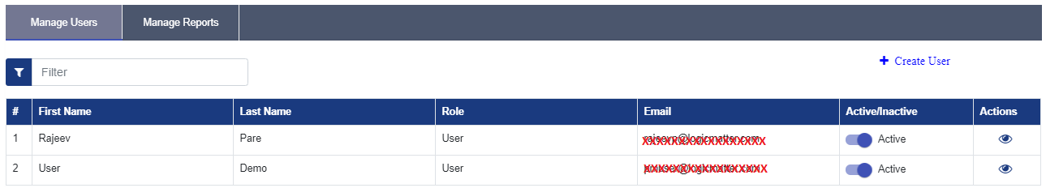

List View columns
- First Name : Provides the First Name of the user
- Last Name: Provide the Last Name of the user
- User Role : Provides information on Role assigned to the user
- Email Address : Users email address
- User Activation Status: Provides option to activate or deactivate user
- Actions: Provides option to view the list of reports assigned to the user

PointMatter Manager can
- Create a New User
- Activate or deactivate a user
- View the list of Reports assigned to the user

Create a New user
To create a new PointMatter user follow these steps:

Step 1: Click on the “Create User” user “Manage users” tab
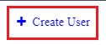

Step 2: Provide user information
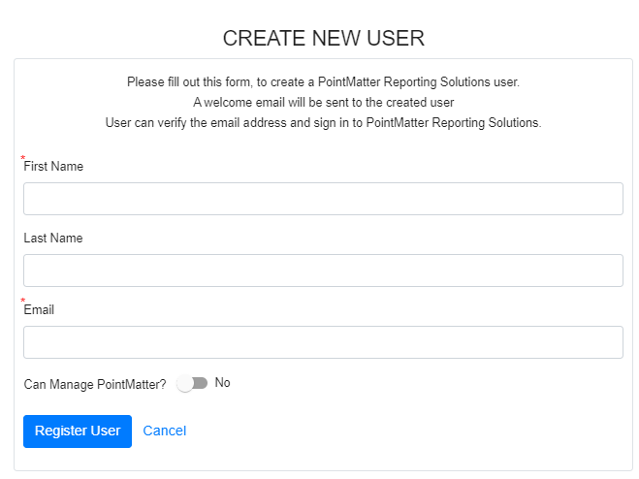

- First and Last Name and email Address
- Select if the user can Manage PointMatter? if selected YES - the PointMatter Manager role will be assigned to the created user.
- Click on Register user

Step 3: A welcome email will be sent to the created user on the given email ID and User can verify the email address and sign in to PointMatter Reporting Solutions.

Activate or Deactivate a user
Use the option in Active/ InActive in the manage user list of Activate or Deactivate a user.
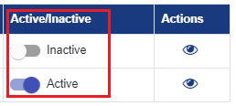
Deactivated users will not be able to login to the PointMatter
If a deactivated user is trying to login to PointMatter, user will get a message about deactivated account .

View and Manage Report Assignment
- Click on the “Assigned Reports” icon under the Action column.
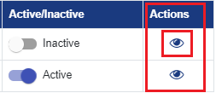
- This will show “List of the Reports”
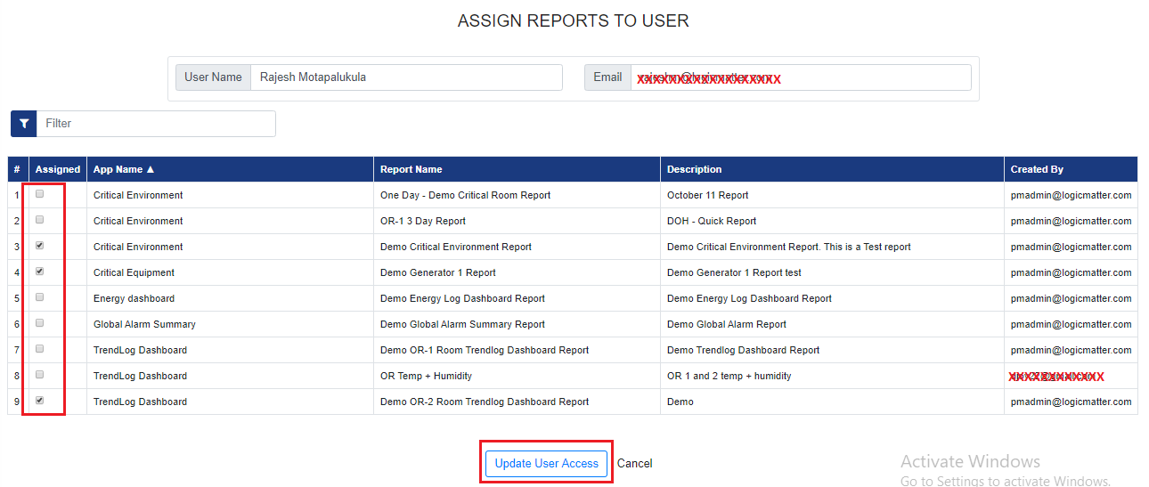
- Reports which are assigned to the user will have the “Assigned” column value as checked.
- To revoke the assignment uncheck the “Assigned” value and press “Update User Access”
- Assigned more reports to the user by Checking “Assigned” value and press “Update User Access”.

If selected user is having a Manager manager role, “Assigned” column will not be displayed for that user.

Template Management
In PRS the Apps provide the ability to extend the standard templates that are pre-configured and add new custom templates designed by Dealers/SI and FM. The PointMatter Template Authoring Guide provides guidance for anyone with basic SQL Server Data Tools (SSDT) experience to build PRS compatible Templates and deploy them using the PM Manager program.

To Author Report Templates the tools needed is SSDT for SQL Server 2017 information is available on the Microsoft Website.
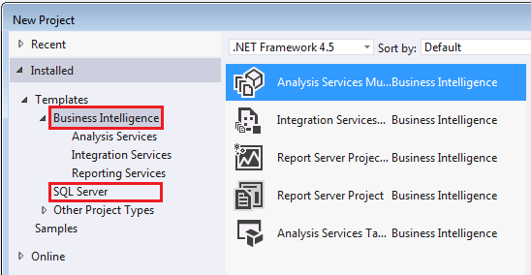

In the current version of PRS the Apps are able to automatically detect custom templates and list them for reporting. However for deployment the users have to either use SSDT or SSMS and the PRS guidelines to deploy and configure custom templates.

Custom Templates
- Install the correct 2017 version of SSDT
- Design the custom templates as per PRS Report Authoring guidelines
- Use steps mentioned in the PRS Template Authoring guide to deploy custom template
- Use PM Portal and select App to create reports using the deployed custom template

System & Data Management
This section is ment for the PM Manager role to see how the data is collected from the BMS SCADA such as Compass. It provides reports to determine the performance and errors of data collection as well as report execution.

System Activity - Dashboard and SLA reports

This is a report that shows the various elements of a Service Level Agreements (SLA) that Dealers can use to see how their service is doing when providing maintenance.

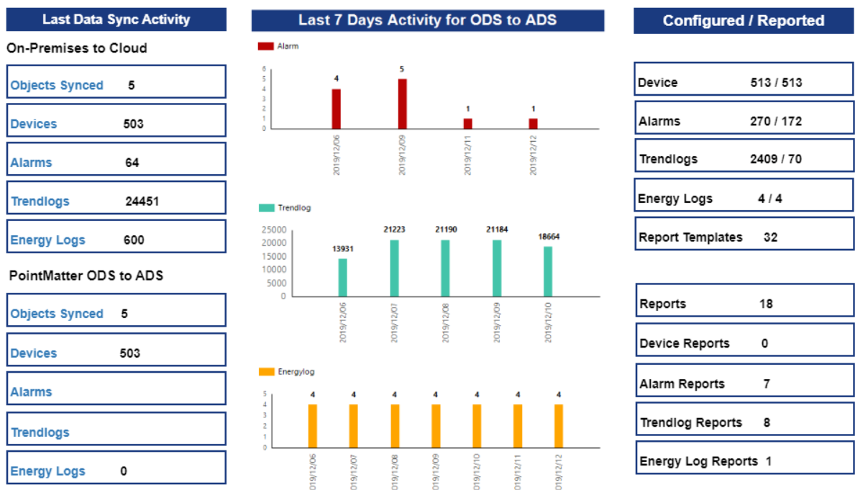

Tenant Information
PointMatter Manager can view the details of the configured Tenant/s along with the PointMatter configuration for the selected tenant.

To view the tenant information click on “Tenant” in side menu bar
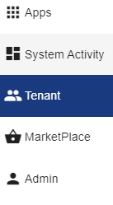
This will open Tenant View page, select the the tenant name
This will show the Tenant details and PointMatter configuration file information for the tenant.
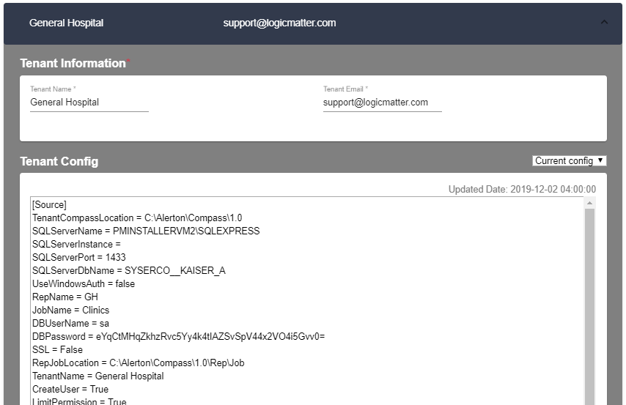

Glossary of Terms

Terms | Description
ADS | Analytical Data Store is a database the stores reportable data
Alarm | An abnormal state of point or device
Apps | End user functionality delivered that has value and can be priced independently
BACnet | Building Automation Control Network protocol
BI | Business Intelligence
BMS | Building Management System
Bundle | End user Apps that combined and sold as a unit
Cloud | AWS/Azure/GCP based Cloud that is used for computing and storage
Compass | The supervisory or SCADA product from Alerton Inc
Customer | The End Customer using the product for their day to day reporting/analysis
Database | A SQL database that stores tables of information
Dealer | Channel partner of OEM
DW | Data Warehouse
Ethernet | The communication protocol between devices and systems
Event | Any state of a point or device that would be of interest to track
Features | Specific functionality that adds end user value for an App or the Platform
FM | Facility Manager
Flow | The data processing steps to imported, transformed and exported from source to target
HMI | Human Machine Interface
IaaS | Infrastructure as a Service
IIoT | Industrial Internet of Things
IoT | Internet of Things
IP | Internet Protocol
IT | Information Technology
LMI | LogicMatter Inc
LM | LogicMatter Inc
Log | A historical capture of the state of a point
Modbus/IP | Modicon Bus for Internet protocol for PLC communication
MSRP | Manufacturer’s Suggested Retail Price
ODS | Operational Data Store is a database is for staging data from any source for data processing
OEM | Original Equipment Manufacturer
On-Prem | Software that can be installed on a server or Virtual Machine on premise of end user
OPC | Object Linking and Embedding for Process Control
OPC Server / Client | The software that enables data movement between systems
OPC-DA | OPC Data Acquisition
OPC-HDA | OPC Historical Data Acquisition
PDS | PointMatter Data Store contains all metadata information for a specific end user Tenant site
Platform | Software framework that hosts end user data, configuration and reports. Also provides UX
PM | PointMatter
PM Portal | PointMatter Portal or Web User Interface
PM Manager | PointMatter Manager that lets Dealers configure and setup PRS Tenants
PO | Purchase Order
Point | A tag is also a point or a specific object in a BACnet system
PointMatter | Set of tools and utilities brought together to provide a solution
Profinet | Ethernet-based communication standard in Industrial devices
PRS | PointMatter Reporting Solution pr PointMatter Reporting Software
SaaS | Software As A Service
SCADA | Supervisory Control And Data Acquisition system
SI | System integrator or Dealer
SLA | Service Level Agreement
Source | The system that provides the information needed for PRS to collect, combine and report
SPLA | Subscription Product License Agreement is a rental agreement for specific product version
Subscription | Is a monthly payment based licensing of software & services
Supplier / Vendor | LogicMatter Inc
T&M | Time and Material
Tags | A point being tracked or captured from any PLC or device
Target | The system that is fed the data or report either external to PRS or within PRS
Template | A container of structure and layout of reports or flows
Tenant | A specific BMS end user site that needs reporting and analytics
Trend | A linear plot of Logs captured for a given point
UX | User eXperience
VM | Virtual Machine
WO | Work Order generated by the Supplier against each PO

Remove

Sample Screens

- Search for ALL

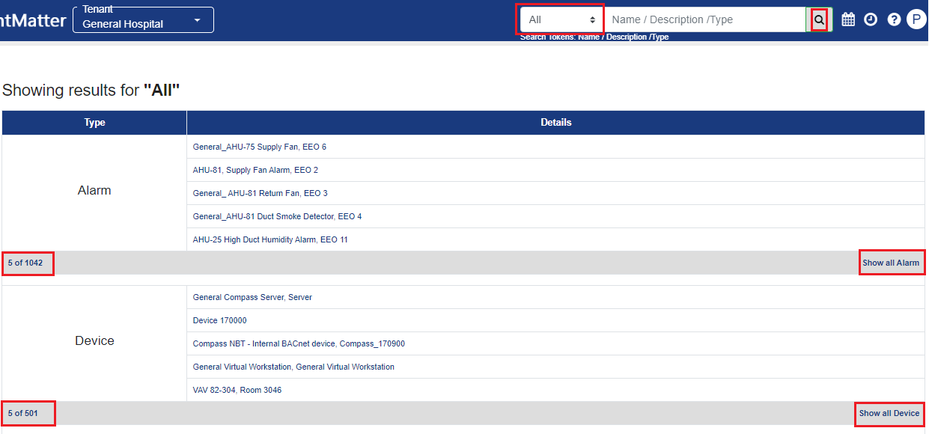

- For TrendsLogs
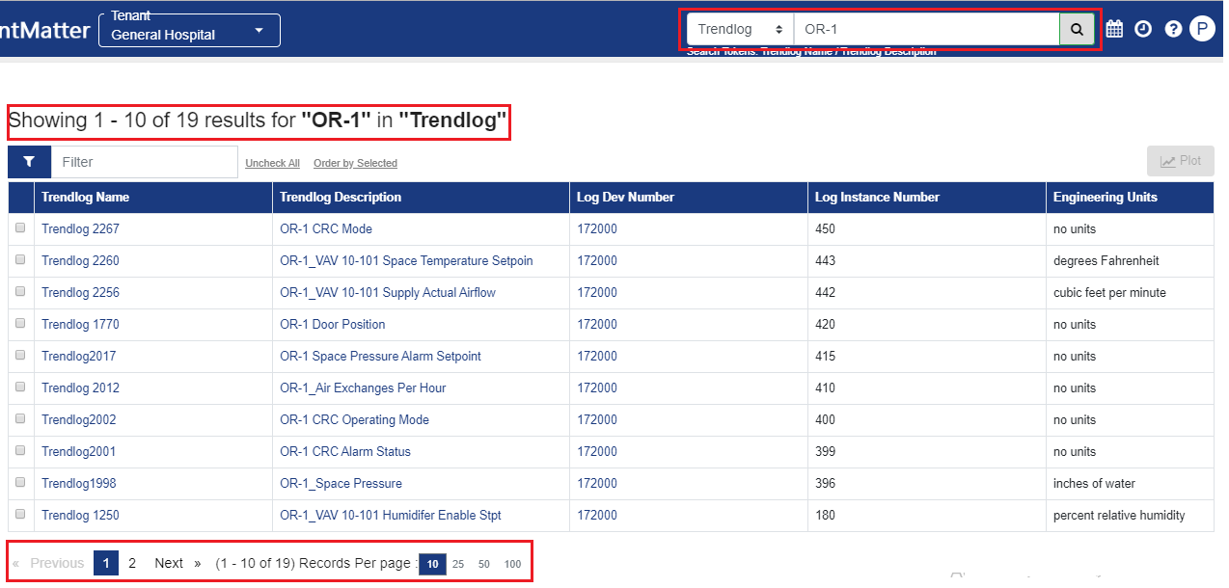

- Trends details
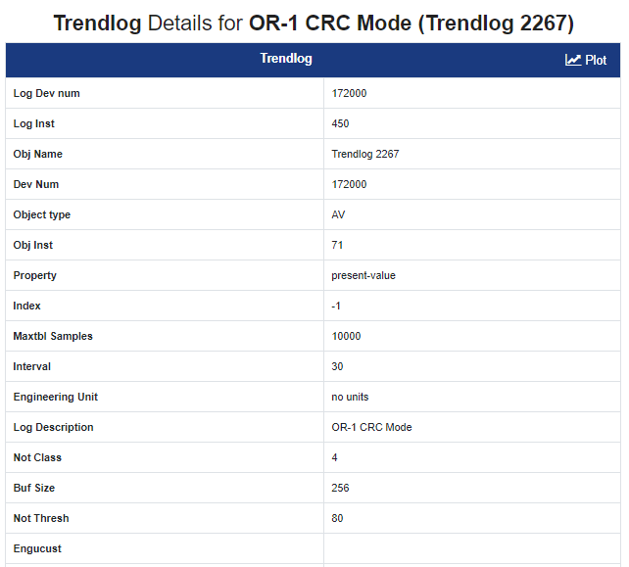

- Search for Reports
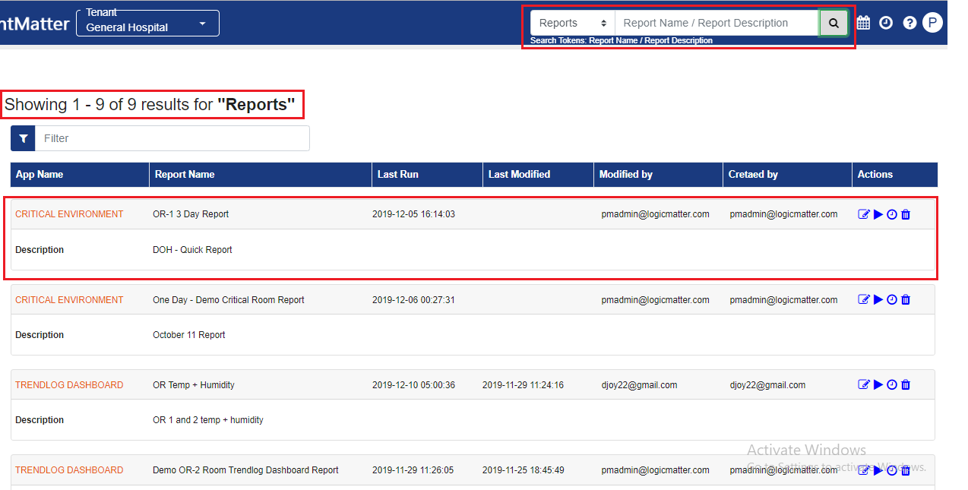

Side Navigation Menu

The left-side navigation menu is available for users with Administration roles. Below is the navigation for accounts that have Administrative privileges.

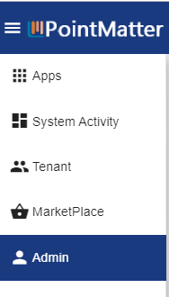

A standard user will only have access to the Apps section of the PointMatter Portal.
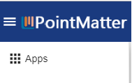

Global Datepicker

The Datepicker is in the header section that lets users pick and apply a date setting that can act as a default analysis period across Apps.

Duration
The duration allows users to pick a specific period in time. The Datepicker provides easy way to select specific periods based upon well known terms i.e yesterday, last week, etc

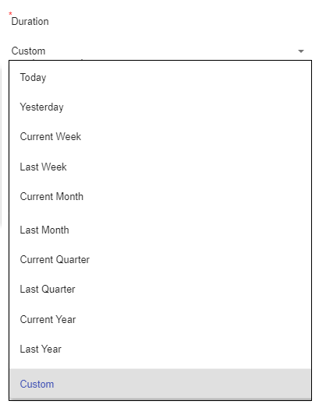

Resolution
The resolution determines the specific granularity of the data being visualized. It enables the system to zoom in and out of data using averageOf (range) type of formula on all data points selected for the duration.
The Datepicker provides an easy way to select specific periods based upon well-known terms i.e Actual, Hourly, Daily, weekly etc.
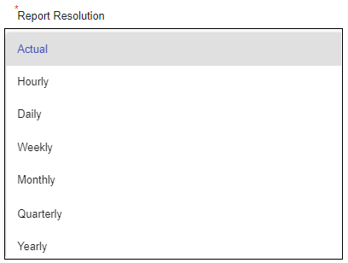

Search for Objects and PM Apps Reports

PointMatter enables the user to search and find the configuration of Objects (Alarm, Device, Energy Log, Point and Trendlog) and Reports created using PointMatter Apps.
Thus a user can access the configuration of any object online and can manage at ease.
Search option is available at the PointMatter Portal App top banner.

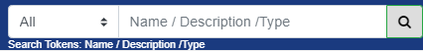
Available search option
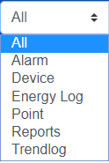

Search for | Search Tokens | Search Result View
All | Object Name,Object Description, Object Type | Search result for All objects  First 5 records for each object will be shown by default  Click on “show all” for respective objects
Alarm | Alarm Name, Alarm Description | Search result for all matching Alarm Records
Device | Device Name, Device Description, Device Number | Search result for all matching Device Records
Energy Log | Energy Log Description | Search result for all matching Energy log Records
Point | Point Name, Point Type, Point Description, Device Number, Point Instance | Search result for all matching Point Records
Trendlog | Trendlog Name, Trendlog Description | Search result for all matching Trends
Reports | Search reports based on name and description | Search result for all matching Reports

Leaving the search box blank will result in all records of the selected object type, available in the PointMatter data store.
To view the specific results, provide a value in the search box that matches with the search tokens, the application will search for the value provided against respective tokens.

For example:
If in the search box user has provided a value “EHU” then application will search for “EHU” token for the selected object type in drop down
To get to the details of the specific object Click on the Name/Description link in the search result table

